Honors Biology- Properties of Water and Solutions Name: ______________________________________

1. How do polar molecules form hydrogen bonds?

2. Circle all hydrogen bonds in the picture below. Indicate the δ+ and δ- ends of the water molecule.
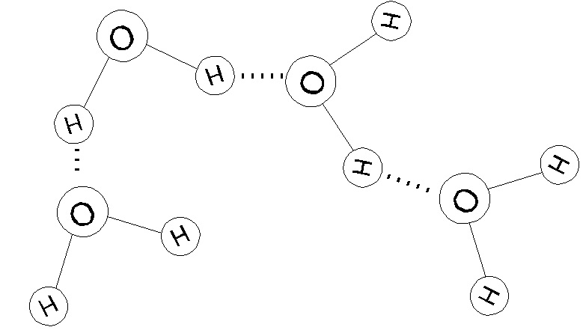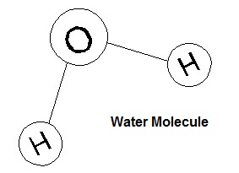

3. What are three unique properties of water?

4. Complete the chart below:
Substance | Acid, Base, Neutral | Substance | Acid, Base, Neutral
pH=2.5 |  | High concentration of OH⁻
low concentration of H⁺ |  | Low concentration of OH⁻
pH = 7 |  | pH =12
pH=10 |  | Equal amounts of H⁺ and OH⁻

5. Identify the solute and the solvent in the following scenarios.
a. Suzy makes lemonade by adding lemon juice, sugar and water together.
Solute:________________________________________
Solvent:_______________________________________
b. Ben makes seltzer water with his new Soda Stream machine.
Solute: ________________________________________
Solvent: _______________________________________

