Name: __________________________________ Period:_________ Date: ________________
Atom Review Worksheet
Complete the following chart:
Particle | Location | Mass | Charge

Find the Missing Numbers (you should know how to find the information to complete the table below)
Element | Atomic Number | Mass Number | # of Protons | # of Neutrons | # of Electrons | # of Valence Electrons
Iron | 26 | 56
Sulfur | 16 | 32
Carbon | 6 |  |  | 6
Fluorine |  | 19 | 9
Calcium | 20 | 40
Nitrogen |  | 14 |  |  | 7
Copper | 29 |  |  | 35

What is a covalent bond?

What is a ionic bond?

Isotope or Different Element?
In each of the following statements, you are given a pair of elements and important information about each. Use this information to determine if the pair if elements are isotopes or different elements. Indicate your answer in the space below (either write Isotope or Different Element).
- Element D has 6 protons and 7 neutrons.
Element F has 7 protons and 7 neutrons. _____________________________

- Element J has 27 protons and 32 neutrons.
Element L has 27 protons and 33 neutrons. _____________________________

- Element X has 17 protons and 18 neutrons.
Element Y has 18 protons and 17 neutrons. _____________________________

- Element Q has 56 protons and 81 neutrons.
Element R has 56 protons and 82 neutrons. ____________________________

- Element T has an atomic number of 20 and
an atomic mass of 40.
Element Z has an atomic number of 20 and
an atom mass of 41. _____________________________

- Element W has 8 protons and 8 neutrons.
Element V has 7 protons and 8 neutrons. _____________________________

- Element P has an atomic number of 92 and
an atomic mass of 238.
Element S has 92 protons and 143 neutrons _____________________________

Name: ______________________________________ Period:_____ Date: _______________

Ions Review

- What is an ion?

- If Oxygen gains 2 electrons from another atom, why is written O⁻² (with a -2)?

- If Sodium loses an electron to another atom, why is it written Na⁺¹ (with a +1)?

- Describe the charge on Mg⁺² ion. Is it a cation or anion?

______________________________________________________________________________
Properties of Water Review

- Use the following terms to label the molecule below: Hydrogen(H), Oxygen(O), -, +

What type of molecule is it: ____________________________

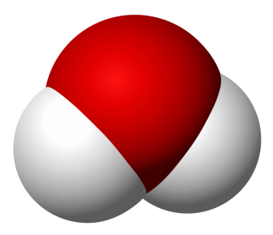

- Use the terms polarity, adhesion, and cohesion to explain what causes the water to rise on the side of a tube.

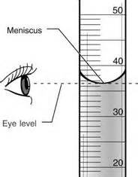

Use the diagram below to answer questions 3 and 4
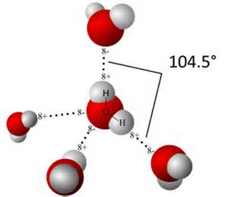
- Describe what is the picture at the right showing?
_______________________________________
_________________________________________
- What type of bond is shown?
_________________________________________

- Given the concentrations of [H+] and [OH-], how can we determine whether the solution is acidic or basic?

- A student mixes strawberry koolaid and water. A pH meter is used to measure pH of 5.4. What kind of solution is strawberry Koolaid?

- In the koolaid mixture, what must there be more of, hydrogen ions or hydroxide ions?

- A student adds an alka-seltzer to the koolaid and stirs. The pH meter now reads 8.3. What was released by the alka-seltzer tablet to cause this change?

- Baking soda is a weak base. Hydrochloric acid is a strong acid. What would happen if these two were mixed?

- How much more acidic is a substance with a pH of 3 than a substance with a pH of 5. Explain your answer.

Organic Chemistry is the study of all compounds that contain bonds between carbon atoms. Carbon has 4 valence electrons so its bonds are strong. Carbon even has the ability to bond with other carbon atoms, forming long chains or even rings. Living things are made up of molecules that consist of carbons covalently bonded to other elements, such as macromolecules.
Macromolecule  (polymer) | Monomer  “building blocks” | Polymers | Examples | Function

Directions: In the space provided, identify the following molecules:
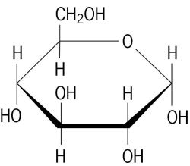
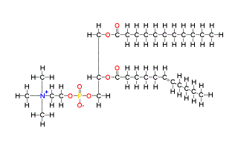

- _______________________________________ 2. ___________________________________________

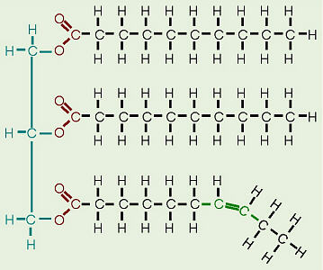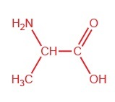

- _______________________________________ 4.______________________________________

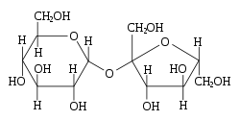
5 ________________________________________

6. Draw an arrow to indicate the peptide bonds in the molecule below:
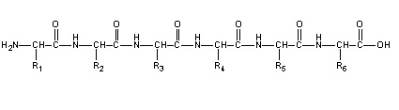

7. Explain how the two amino acids would join together to form a dipeptide and draw the final molecule. Be detailed.
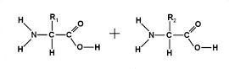

Unit 2: Enzymes Review
- What type of organic molecule is an enzyme? __________________________

- What is a catalyst and why is an enzyme considered a biological catalyst? _________________________________________________________________________________________________________________________________________________________________________________________________________________________________

- Label enzyme activity below.
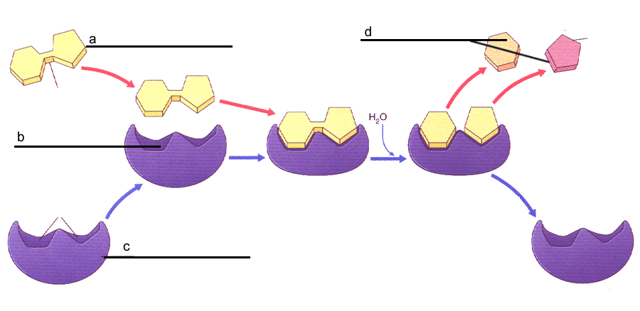
- Describe the diagram above using the terms you used to fill in the diagram with.
_______________________________________________________________________________________________________________________________________________________________________________________________________________________________________________________________________________________________________________________________________________________________________________________

- Answer true of false to the following statements:
a. _______ Enzymes interact with specific substrates
b. _______ Enzymes change shape after a reaction occurs
c. _______ Enzymes speed up reactions.
d. _______ One enzyme can be used for many different types of chemical reactions.
6. Circle the correct effect.
a. Raising the temperature slightly toward optimal temperature will _____________ the rate of reaction.
increase | decrease | not change

b. Boiling temperature will _______________the rate of reaction.
increase | decrease | not change

c. Changing the pH toward the optimal pH will _____________the rate of reaction.
increase | decrease | not change

- What four factors can affect the activity of an enzyme?

- ____________________________________________________
- _____________________________________________________
- _____________________________________________________
- _____________________________________________________

Use the 2 graphs below to answer Questions 8, 9, and 10.
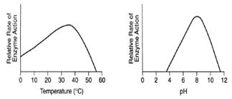

- What is the optimal pH that this enzyme functions at? _________________________

- What is the optimal temperature that this enzyme functions at? __________________

- What happens when the pH is 2? ______________________________________________________________________

- Why are the active site and the substrates in an enzyme-catalyzed reaction often compared to a lock and key? ____________________________________________________________________________________________________________________________________________________________________________________________________________________________________________________________________________________________________________

- Explain the four ways an enzyme can reduce the activation energy of a chemical reaction?
____________________________________________________________________________________________________________________________________________________________________________________________________________________________________________________________________________________________________________

