Name: ____________________________ Period: ____ Date:_________
Practice Test
Directions: Please complete the following questions. You may use your notes and textbook to answer the following questions.
Use the following paragraph and table to answer questions 1 and 2.
The common cold is caused by a virus that enters the human body and causes mild, flu-like symptoms. Some people believe that the common cold can be treated by digesting the herb Echinacea. The following table shows results from a study conducted to explore the effects of Echinacea on children with colds.
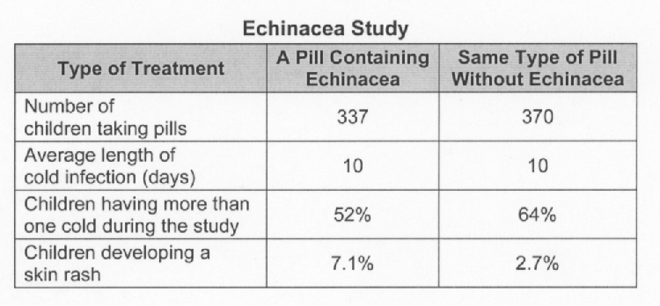
___ 1. Data in the table show that the use of Echinacea can______?______.
A. reduce the length of cold infection from 10 to 7 days
B. increase the incidence of colds in children from 52% to 64%
C. increase the percent of children with skin rash from 2.7% to 7.1 %
D. reduce the numbers of children having colds from 370 to 337 cases

___ 2. A possible conclusion from the data is that Echinacea______?______.
A. is a safe remedy for the common cold
B. is effective only for children
C. has side effects
D. reduces the length of colds

____ 3. It is very difficult to develop a vaccine against the common cold. The reason for this is that the common cold virus______?______.
A. hides in the digestive system
B. changes rapidly due to high mutation rates
C. includes RNA as its genetic materials
D. is too small for the immune system to detect

____ 4. What is accomplished by treating a person who has a bacterial infection with antibiotics?
A. Immunity to future infections
B. Weakening of the person’s immune system
C. Reduction in the duration and intensity of the infection
D. Modification of bacterial DNA to make the bacteria harmless

____ 5. ___________ are used to prevent viral infections and ____________ are used to kill bacteria.
A. Drugs/Vaccines
B. Antibiotics/Vaccines
C. Vaccines/Antibiotics
D. Drugs/Viruses

___ 6. In the early days of antibiotic use, penicillin and sulfanamide were used to successfully treat various bacterial infections. In later years these antibiotics have become less effective because
A. of lack of quality control
B. of bacteria developing resistance
C. doctors prescribing the wrong antibiotic
D. these antibiotics work better on viruses

Typhoid Mary
Use the following paragraph to help you answer questions 7 and 8.
Mary Mallon was the first known "healthy carrier" of typhoid fever in the early 1900’s. Health officials in New York investigated the households in which she worked as a maid and determined that she had transmitted the disease to dozens of people.
Typhoid fever is caused by the bacterium Salmonella typhi. It is generally transmitted by eating food and drinking water that has come into contact with contaminated fecal matter. Symptoms of typhoid fever include headache, fever, diarrhea, and loss of appetite.
_____ 7. Typhoid fever is BEST treated with ______________________________.
A. surgery
B. vaccines
C. antibiotics
D. gene therapy

____8. In 1910, Mary Mallon was banned from ever working in kitchens again. Five years later, health officials suspected that Mary had violated the ban. What most likely alerted health officials to the fact that Mary might be working in kitchens again?
A. A new typhoid outbreak in New York
B. The fact that she changed her name to Mary Brown
C. Identification of other healthy carriers in New York
D. Discovery of the typhoid bacterium on local vegetables.

9. Label each of the following diagrams as a bacteria or virus.
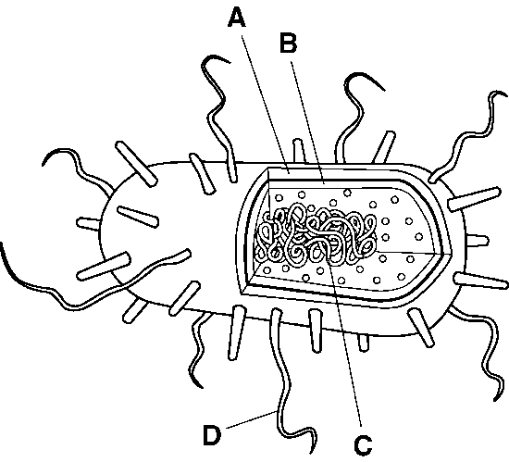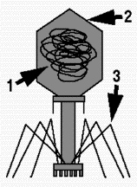
E.
F.
EE.

Label each structure in the diagram.
A. ______________________ E. __________________________
B. ______________________ F. ___________________________
C. ______________________
D. ______________________

____ 10. When a person is prescribed with strong antibiotics, probiotic yogurt is often recommended. The purpose of the probiotic yogurt is to
A. continue to kill harmful bacteria
B. maintain normal bacteria levels in the gastrointestinal tract
C. give the person energy
D. to settle their stomach

____ 11. Food stored in a refrigerator will keep longer because the bacteria that spoil food
A die at low temperatures.
B. take longer to multiply at low temperatures.
C. require light to live.
D. grow more slowly in the dark.

USING SCIENCE SKILLS

A student placed a disk of filter paper in each of the following solutions: disinfectant 1, disinfectant 2, disinfectant 3, and distilled water. While the four disks were soaking in their respective solutions, she streaked a sterile nutrient agar dish with a culture of E. coli bacteria. Then, she placed each disk carefully onto the nutrient agar dish, placed the lid on the dish, taped it shut, and incubated the dish at 37ºC for several days. Figure 19-4 shows how the nutrient agar dish looked on Day 1 and Day 4.

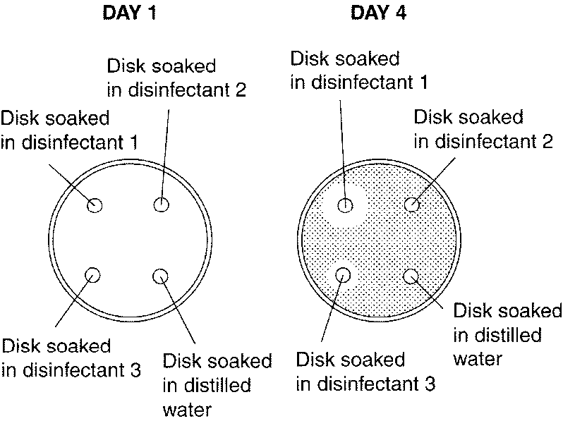

Figure 19–4
Use the paragraph and diagram above to answer questions 12 – 15

12. (2 pts) Designing Experiments Based on Figure 19-4, what is the student probably trying to test?

13. (1 pt) Controlling Variables What is the control group in the experiment shown in Figure 19-4?

14. Inferring Look at the dishes in Figure 19-4.
a. (1pt) Which disinfectant was the most effective at controlling the growth of E. coli?

b. (1 pt) How do you know?

15. (2 points) Drawing Conclusions Look at the results of the experiment shown in Figure 19-4. Why do you think the different disinfectants are not equally effective against the E. coli bacteria?

