Mitosis Cell Division Worksheet Name _____________
Period Date
Instructions:
- Draw phase of mitosis in the column labeled picture
- Find the appropriate description from the list given and copy it in the description box. Refer to pages 245-246 in text for additional guidance.

Mitosis – Autosomal Cells (all cells except sex cells)
Phase (PMATC) | Picture | Description
Interphase
(not considered a phase)
Prophase
Metaphase
Anaphase
Telophase
Cytokinesis

The cell cycle: Notice how much time it is in Interphase!

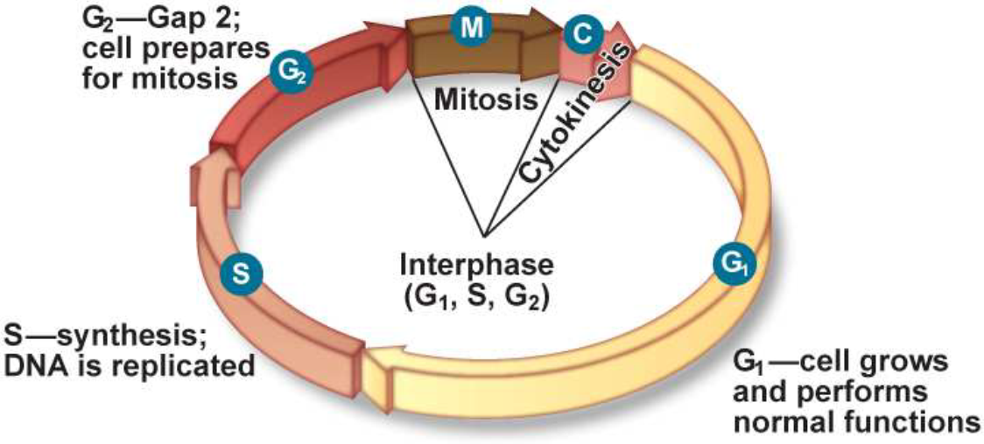

Directions: Use the description below to complete your mitosis table

Cell Division Ca
The chromosomes line up across the center of the cell.
The chromosomes gather at opposite ends of the cell and two new nuclear envelopes will form. The cell is starting to divide.
Chromatin condenses into chromosomes (92 total). Nuclear envelope starts to disappear. Centrioles move toward poles and spindles form.
The cell grows and replicates DNA
Chromosomes appear as threadlike coils called chromatin
(# chromosomes doubles from 46 to 92)
The cytoplasm is pinched in half. Two cells are formed identical to the parent cell, each with identical set of chromosomes
Diploid cells contain two complete sets (2n) of chromosomes (humans 2x23 = 46).
Chromosome move toward the opposite ends (poles)

