College Prep Study Guide For Biotechnology Unit
Biology, Chapter 13.1-13.4, pages 318-333
Use your notes, text, returned work, PowerPoint (available on my website) in addition to the following questions to prepare for this unit test.

- What is selective breeding?

- What is the difference between inbreeding and hybridization?

- Give an example of inbreeding and hybridization.

- What is genetic engineering?

- What do restriction enzymes do?

- Label the diagram of electrophoresis.
- ______________ (positive or negative)
- ______________ (positive or negative)
- _______________
- _______________
- _______________
- _______________
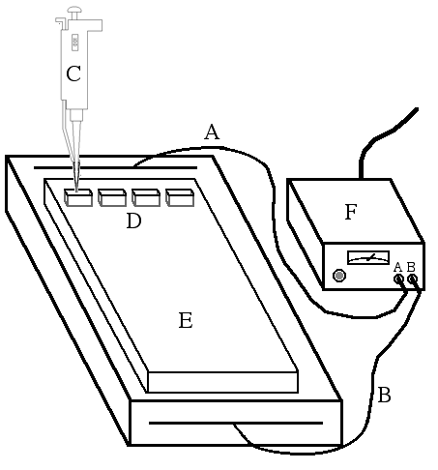

- Use the DNA fingerprint to determine:

- Who is the murderer? ____________
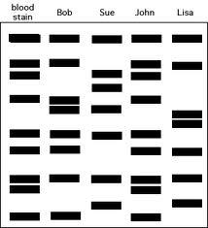
- Which male horse is the father? _________________
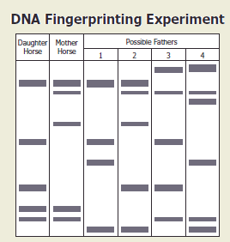

- What are DNA fingerprints used for and why are they effective?

- Label the diagram below
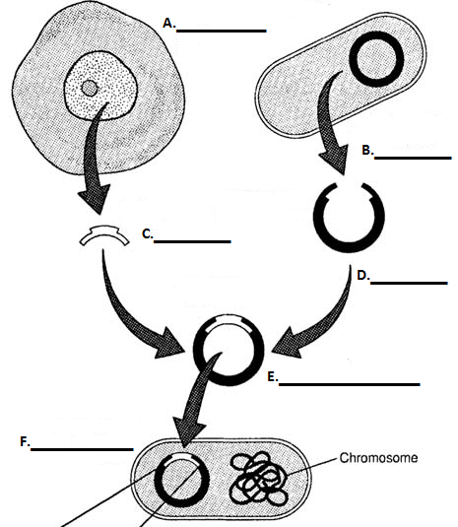

- Describe the pros and cons of genetically engineering food (GMO)

Pros | Cons

