Name: ______________________________ Period: ____ Date: _______
Study Guide for Biochemistry Unit
- Match the definitions to the terms.

  - ___ Macromolecule
  - ___ Monomer
  - ___ Polymer
  - ___ Carbohydrate
  - ___ Monosaccharide
  - ___ Disaccharide
  - ___ Polysaccharide
  - ___ Lipid
  - ___ Nucleic Acid
  - ___ Nucleotide
  - ___ Protein
  - ___ Amino Acid
  - ___ Enzyme
  - ___ Dehydration Synthesis
  - ___ Chemical Reaction
  - ___ Reactants
  - ___ Products
  - when elements or molecules are brought together broken apart forming new elements or molecules
  - Fat, oil, wax, or steroid, made of fatty acids and glycerol
  - RNA or DNA polymer, important in transferring hereditary information
  - Monomer of carbohydrate
  - Made of C, H, O; source of short term energy
  - Monomer of protein
  - Monomer of nucleic acid
  - When two monomers are brought together and form a polymer and a water molecule
i. molecules or elements present before a chemical reaction.
j. Molecules or elements present after a chemical reaction
k. protein that regulates speed of chemical reaction.
l. polymer of carbohydrate
m. macromolecule that functions in the regulation of chemical reactions, muscle & bone formation, fights disease, and control movement of substance into and out of cells.
n. two monomers of a carbohydrate added together.
o. very large molecule
p. made of many small monomers
q. building blocks of macromolecules, makes up a polymer

Make flashcards for the terms above. Flashcards should have the term on one side and the definition on the other. In addition, you should include an example of each term. An example of a monosaccharide would be “glucose”.
- Monomers could be called the:
  - Reactants
  - Building blocks of life
  - Small molecules that make up polymers
  - All of the above

- What happens during dehydration synthesis? List the substances that are present before and after dehydration synthesis.
___________________________________________________________________________________________________________________________________________________________________________________________________________________________________________________________________________________________________________________________________________________________________________________________________________________________________

Enzymes Review
- What type of organic molecule (macromolecule) is an enzyme? __________________________

- What is a catalyst and why is an enzyme considered a biological catalyst (refer to activation energy in your answer)? ________________________________________________________________________________________________________________________________________________________________________________________________________________________________________________________________

- Label enzyme activity below.
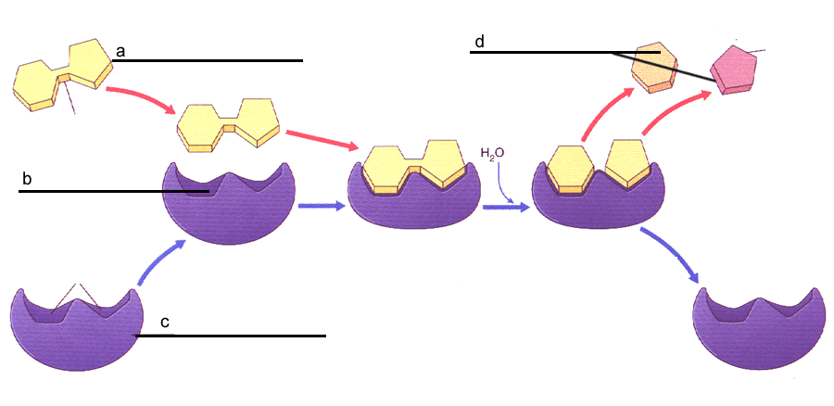
- Describe the diagram above using the terms you used to fill in the diagram with.
________________________________________________________________________________________________________________________________________________________________________________________________________________________________________________________________________________________________________________________________________________________________________________________________

- Answer true of false to the following statements:
  - _______ Enzymes interact with specific substrates
  - _______ Enzymes change shape after a reaction occurs
  - _______ Enzymes speed up reactions.
  - _______One enzyme can be used for many different types of chemical reactions.

6. Circle the correct effect.
a. Raising the temperature slightly will _____________ the rate of reaction.
increase | decrease | not change
b. Boiling temperature will _______________the rate of reaction.
increase | decrease | not change
c. Changing the pH toward the optimal pH will _____________the rate of reaction.
increase | decrease | not change

- What three factors can affect the activity of an enzyme?

- ____________________________________________________
- _____________________________________________________
- _____________________________________________________

- Draw a pH scale from 0-14 and label it according: acidic, basic, neutral.

Use the 2 graphs below to answer Questions 9, 10, and 11.
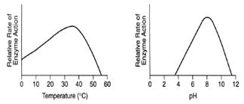

- What is the optimal pH that this enzyme functions at? _________________________

- What is the optimal temperature that this enzyme functions at? __________________

- What happens when the pH is 2? ________________________________________________________________________________________________________________________________

- What does it mean when an enzyme is denatured?

- Why are the active site and the substrates in an enzyme-catalyzed reaction often compared to a lock and key?
________________________________________________________________________________________________________________________________________________________________________________________________________________________________________________________________________________________________________________________________

- How are enzymes named?
________________________________________________________________________________________________________________________________________________________________________________________________________________________________________________________________________________________________________________________________

- Describe how enzyme or substrate concentration affects enzyme activity.
________________________________________________________________________________________________________________________________________________________________________________________________________________________________________________________________________________________________________________________________

Scientific Method and Chemistry:
Explain how a hypothesis is different from a theory: __________________________________________________________________________________________________________________________________________________________________________________________________________________________________________
How many variables are changed in a controlled experiment? Explain why this is important. __________________________________________________________________________________________________________________________________________________________________________________________________________________________________________
List the three subatomic particles found in an atom of carbon and indicate the charge of each.
- ________________________________
- ________________________________
- ________________________________

Fill in the blank:
- An atom that has lost or gained an electron is called a(n): ___________________.
- A bond in which atoms share electrons is called a(n) ______________________ bond.
- The electrons located on the outer most shell of an atom are called __________________________.
- A positively charged atom is called a(n) ______________________.
- A negatively charged atom is called a(n)_____________________.
- The atomic number is the number of __________________ in an atom. This the same as the number of __________________ in an atom.
- The atomic mass is the ________________ plus the _______________.
- The variable that is changed in a controlled experiment is called the _________________ variable.

