Name: _______________________________________ Period: ____ Date: _______
WHICH PLANT IS MOST CLOSELY RELATED TO THE CUROL PLANT?
Setting: “Curol” (Botanus curus) is a fictitious plant extract that has the ability to effectively treat cancer. The “Curol” plant is currently an endangered species due to overharvesting. Scientists think that one of these related plants (Species X, Species Y, Species Z) may provide similar therapeutic benefits. However, they first need to determine which species is most closely related to “Curol”. Examine the following plant structures for similarities.
- Plant structure
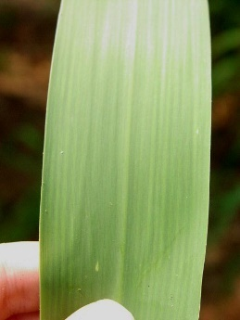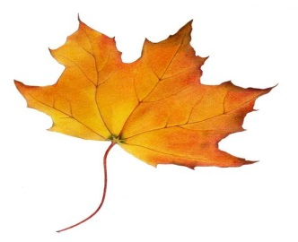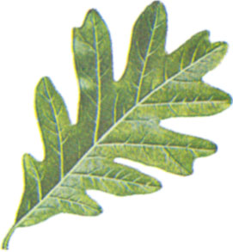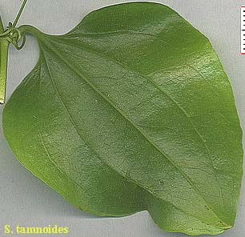
“Curol” (Botanus curus) Species X Species Y Species Z
Which plant’s leaves look most similar to Curol? ________________________________
- Seed structure:
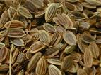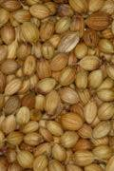
“Curol” (Botanus curus) Species X
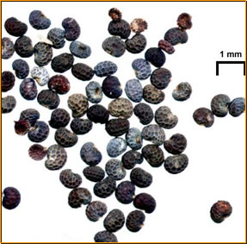 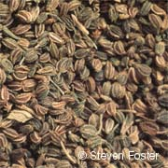 Species Y Species Z
Which plant’s seeds are most similar to Curol's seeds? ____________________________________
Analyze the molecular data provided.
- Scientists tested the extracts of plants for presence of enzyme produced by Curol by adding an “indicator solution” to each extract. Observations of the reaction between the plant extract and the indicator solution were recorded after application. Enzymes are a protein that are produced by specific sequences of nucleotide bases in the DNA. Small changes in those bases may result in the production of different enzymes.

Plant Extract | Observations
Curol (Botanus curus) | Fizzed a little
Species X | No fizzing
Species Y | Fizzed a little
Species Z | Fizzed a little

Based on the results of the indicator reaction, which plant is most similar to Curol?

- A gel electrophoresis was run on a DNA extract for each plant species.
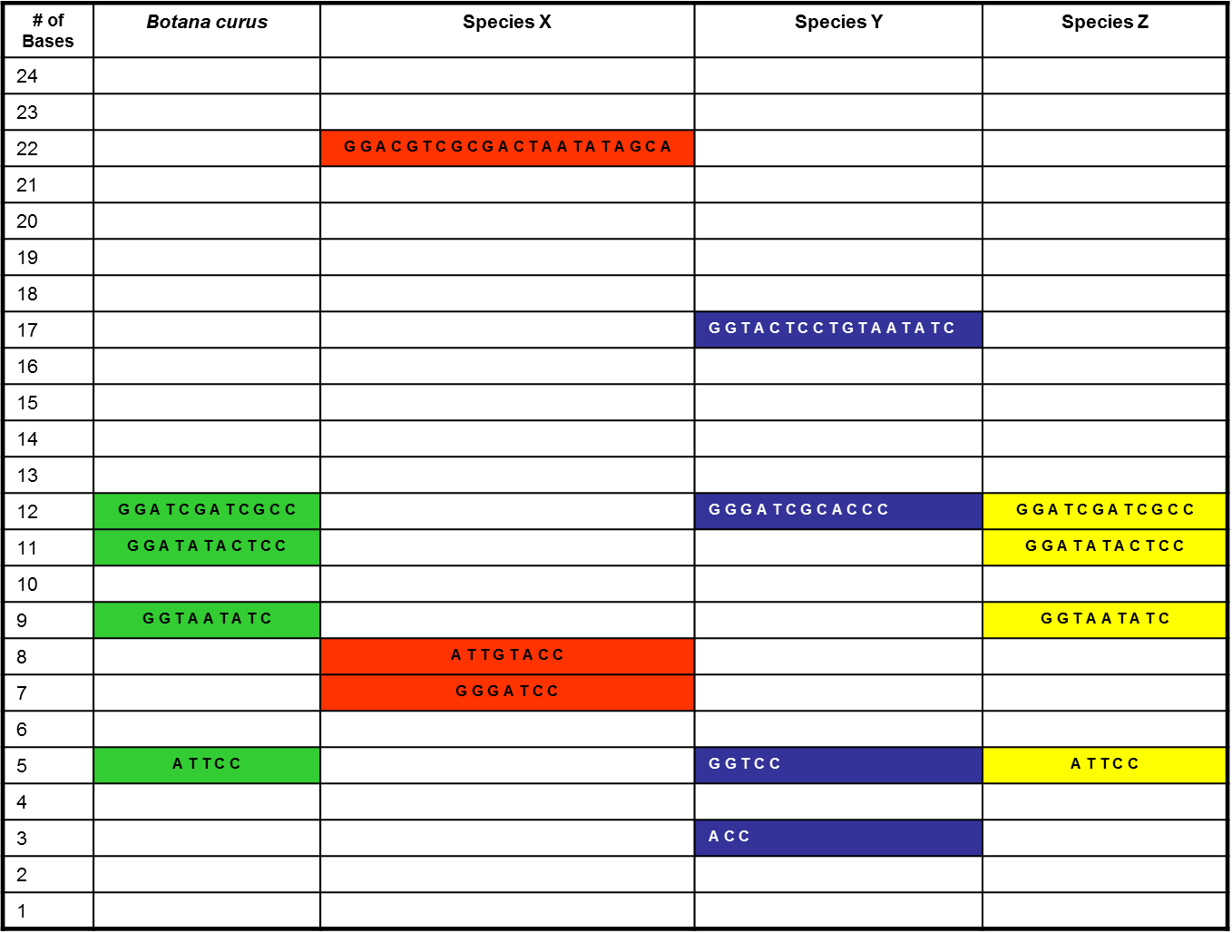
Based on the gel electrophoresis, which plant is most similar to Curol (Botanus Curus) ? _____________

- Using the DNA data for each species, scientists were able to predict which amino acids would be produced for each species. Compare the sequences of amino acids and determine which plant species are most similar.
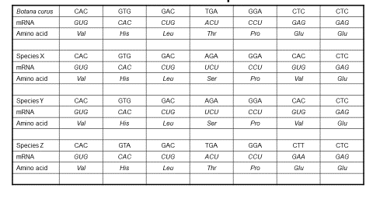
Which plant is most similar to Curol? _________________________

Compare the results of each test. Which plant do think is mostly closely related to “Curol”?
Test | Indicates species most similar to “Curol” (Botanus curus)
- Structural Characteristics of Plant
- Seed Structure of plants
- Enzyme Presence
- Gel Electrophoresis
- Amino Acids

Write a paragraph explaining how you made your determination. Support your determination with specific evidence collected.

Did your determination change after you analyzed the molecular evidence? Describe how you used DNA evidence to support your determination.

What role does DNA play in defining relationships among species that may look physically different but are genetically related?

