BIOLOGY (CP) Mid-Term Review Packet 2016-2017
This exam will cover all the material we’ve learned so far this year. It is highly suggested that you focus on class notes, handouts and the text when preparing for this exam.

Unit 1: Biochemistry/Enzymes (Chapter 2)
- Macromolecule types & function
- Chemical reactions/neutralization reactions
- Acids and bases and the pH scale
- Role of enzymes in chemical reactions

Unit 2: Cell Structure and Function (Chapters 7)
- Structure and function of cells (organelles)
- Transport of materials into/out of cells (diffusion, osmosis, active transport)

Unit 3: Bacteria & Viruses (Chapter 19)
- Basic structure of bacteria & viruses
- How bacteria/virus is transmitted
- Treatment of bacterial/viral infection
- Use of bacteria & virus in daily lives (food, oil clean up, etc..)
- Prevention of transmission of bacteria/virus

Unit 4: Photosynthesis and Cell Respiration (Ch 8-9)
- Photosynthesis (transfer of light energy to chemical energy)
- Cellular respiration: aerobic and anaerobic
- Formulas for photosynthesis/respiration
- Fermentation

Unit 5: DNA and Protein Synthesis (Chapter 12)
- DNA and RNA structure
- DNA replication
- Transcription and Translation
- Protein Synthesis
- Mutations

Unit 6: Biotechnology (Chapter 13)
- Selective Breeding
- Inbreeding
- Hybridization
- Electrophoresis
- PCR
- Transgenic Organisms
- Genetic Variation
Read each scenario and identify the IV, DV, constants, control group, experimental group. Write a title and state a hypothesis
Scenario #3: Aloe vera and Planaria
Jackie read that Aloe vera promoted healing of burned tissue. She decided to investigate the effect of varying amounts of Aloe vera on the regeneration of planaria. Planaria are aquatic flat worms that regenerate body parts when severed. Jackie bisected the planaria to obtain 10 parts (5 head sections and 5 tail sections) for each experimental group. She applied concentrations of 0%, 10%, 20%, and 30% Aloe vera to the groups. Fifteen mL of Aloe vera solutions were applied. All planaria were maintained in a growth chamber with identical food, temperature and humidity. On day 15, Jackie observed the regeneration of planaria parts and categorized the development as full, partial, or none.
- Title: __________________________________________________________________

- Hypothesis: ____________________________________________________________________________________

____________________________________________________________________________________

- Independent variable (IV): _______________________________________________

- Dependent variable (DV):_________________________________________________

- Control Group (CG):_____________________________________________________

- Experimental Group (EG):________________________________________________

- Controlled Variables: ______________________________________________________________

- How could you improve this experiment? _________________________________________________
______________________________________________________________________________________________________________________________________________________________________________

CHARACTERISTICS OF LIFE
Name the 8 characteristics of life, and give an example for each characteristic.
Characteristic | Example
1.

2.

3.

4.

5.

6.

7.

8.

Unit 2: CHEMISTRY and BIOCHEMISTRY
- Complete the following chart, naming the parts of the atom:
Particle | Location | Charge
Proton
Neutron
Electron

- Identify whether the following are acid or bases or neutral.
pH 2.3 = ________________________________________________________________________
pH 7.0 = ________________________________________________________________________
pH 13 = _________________________________________________________________________
- Organic Chemistry is the study of all compounds that contain bonds between carbon atoms. Carbon has 4 valence electrons so its bonds are strong. Carbon even has the ability to bond with other carbon atoms, forming long chains or even rings. Living things are made up of molecules that consist of carbons covalently bonded to other elements, such as macromolecules. Fill in the following table.
Macromolecule  (polymer) | Monomer  “building blocks” | Polymers | Examples | Uses
 |  | Disaccharides-double sugars  Polysaccharides-many sugars | Glucose, fructose, galactose  Sucrose  Starch-plants  Glycogen-animals  Cellulose-plants  Chitin-insects
 |  | Saturated (all single bonds)  Monounsaturated (one double bond)  Polyunsaturated (two or more double bonds)  Phospholipids (phosphate replaces a FA) | Butter  Soft margarine  Olive oil  Cell membrane  Cholesterol  Testosterone  Progesterone  Beeswax (paraffin)
 |  | Dipeptide (2 amino acids)  Polypeptide (many Amino acids) | Enzymes  Muscles  Skin  Some hormones
 |  | DNA  RNA | Stores and transmits genetic information

Enzyme Structure & Function
4. Most enzymes are what type of macromolecule? __________________________
5. Enzymes act as __________________ in reactions.
6. Are enzymes permanently changed in the chemical reactions they are involved in? Yes or No
7. Will an enzyme work on any substance? Explain.

8. Can enzymes be reused?
9. What ending is found on the name of many enzymes?
10. Give 2 examples of enzymes with this ending.

11. How does an enzyme work?

12. What effect does an enzyme have on activation energy needed to start a reaction?

13. What is meant by the term substrate?

14. What is meant by active site?

15. What three factors can affect the activity of an enzyme? How?

- ex. Temp needs to be around body temp (98.6 F)
- _____________________________________________________
- _____________________________________________________

16. What is the effect of high temperature on an enzyme (running fever)?

17. What temperature do most enzymes do best at? _______________ºC
18. Most enzymes function well at a pH near ______________.
Use the 2 graphs below to answer Questions 19, 20, and 21.
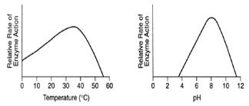

19. What is the optimal pH that this enzyme functions at? _________________________

20. What is the optimal temperature that this enzyme functions at? __________________

21. What happens when the pH is 2? ______________________________________________________________________

Unit 3: Cells and Cellular Transport Review Worksheet
Cells and Organelles
- List the levels of biological organization in multicellular organisms from most simple to complex.
(cell, organism, organs, molecules, organelles, organ system, atom, tissue)

- Make a Venn diagram comparing/contrasting prokaryotic and eukaryotic cells.
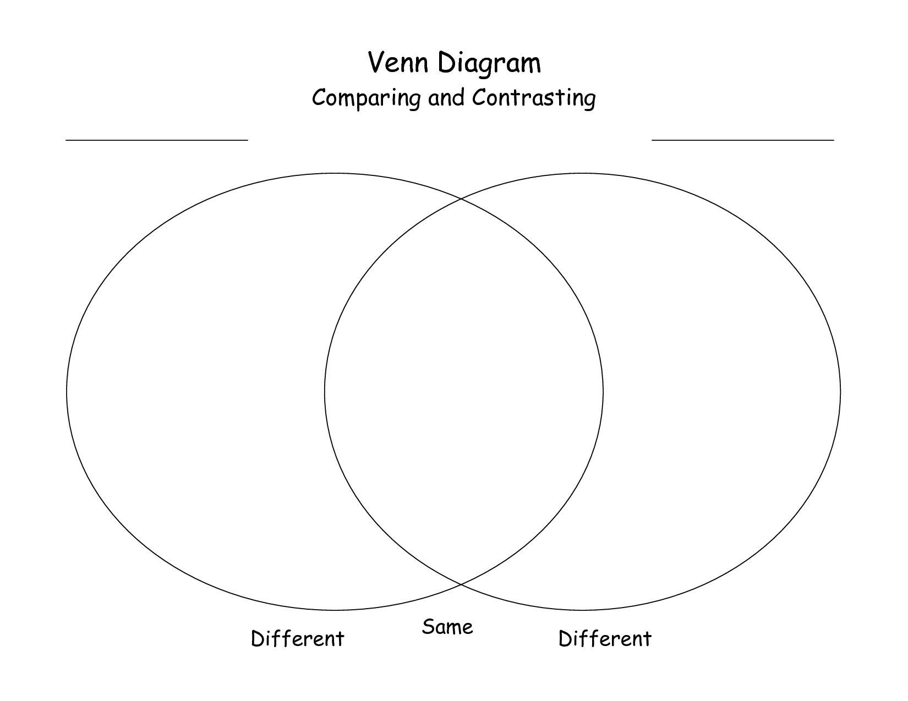

MATCHING: Match the terms below to the following descriptions.

A. ribosomes D. nucleolus G. plasma membrane (cell membrane) J. lysosomes
B. cell wall E. cytoplasm H. rough endoplasmic reticulum K. Golgi apparatus
C. nucleus F. mitochondria I. Smooth endoplasmic reticulum L. vacuole
M. chloroplast

1_______ The structure in the nucleus which manufactures ribosomes for protein synthesis.

2_______ Cellular structure that regulates what enters and leaves the cell.

3_______ Organelles that store materials such as water, salts, and carbohydrates. They may occupy a large space within plant cells.

4_______ Helps to support, strengthen and protect the cell. Not found in animal cells.

5_______ Photosynthetic organelles found in many plant cells only.

6_______ A system of channels that transport proteins through the cell.

7_______ The liquid inside the cell that all the organelles are suspended in.

8_______ Organelles which provide cells with energy by using sugar as a fuel source.

9_______ Contain chemicals and enzymes necessary for digesting certain materials in the cell.

10_______ A system of channels that manufacture carbohydrates and lipids and transport them through the cell.

11_______ Organelle that collects, modifies and packages chemicals made at one location in a cell and secretes finished products to be used at another cellular local.

12_______ The organelle responsible for manufacturing proteins. (Be specific!)

13_______ The information and control center of the cell. Contains genetic information.

14. Which organelles are only found in plant cells?

15. Describe the process of protein synthesis, starting from DNA and ending with a protein.

Cell Transport
      - Match the following substances with their description
X= Word Bank: solution
0= solvent
X+0= solute
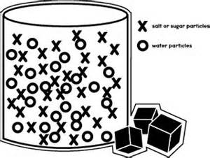
X represents sugar molecule
O represents water molecule
2. How is active transport different than simple diffusion and facilitated diffusion?
_________________________________________________________________________________________
_________________________________________________________________________________________

3. Why does a plant like celery get limp when placed in a hypertonic solution?
__________________________________________________________________________________________
__________________________________________________________________________________________

- Complete the table by checking the correct column for each statement:
STATEMENT | Isotonic Cell(s) | Hypotonic Cell(s) | Hypertonic Cell(s)
a. The concentration of dissolved substances (stuff) in the solution is lower than the concentration inside the cell.
b. When a cell is placed in this solution, water will enter the cell by osmosis resulting in osmotic (turgor) pressure (causes a cell to swell).
c. The concentration of dissolved substances (stuff) in the solution is the same as the concentration inside the cell.
d. The concentration of dissolved substances (stuff) in the solution is higher than the concentration inside the cell.(causes a cell to shrink)
e. When this solution is injected into the body no cell disruption occurs because no net osmosis occurs.
f. Putting a plant in this solution will result in water loss and cause the plant to wilt.

- Explain the diagram below in terms of movement of particles during cellular transport.

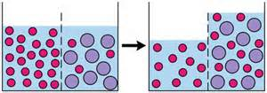

- Write a definition for the following terms:

Passive Transport –

Active Transport –

Selectively Permeable –

Diffusion –

Facilitated Diffusion –

Osmosis –

Endocytosis –

Exocytosis –

- Label the three images below as isotonic/ hypertonic/ hypotonic (with regard to the solution the cell is placed in)
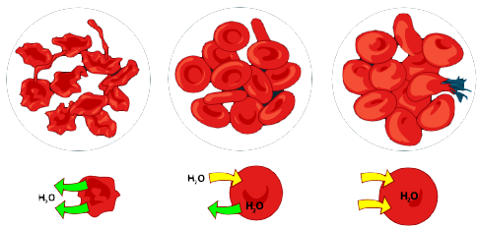
8. Movement across the cell membrane that does not require energy is called
[ active / passive ] transport.
9. The difference in the concentration of a substance across a space is called a concentration [ equilibrium / gradient ].
10. If there is a concentration gradient, substances will move from an area of high concentration to an area of [ equal / low ] concentration.
11. The cell membrane is [ selectively permeable / impermeable ].
12. [ Equilibrium / Diffusion ] is the simplest type of passive transport.
13. The diffusion of water through a selectively permeable membrane is called [ osmosis / diffusion ].
14. A solution that causes a cell to swell is called a (hypotonic / hypertonic) solution.

Unit 4: Bacteria and Viruses
1. Bacteria are referred to as ___________________ (Eukaryotic / Prokaryotic).
2. The three shapes of bacteria are ____________________ (which is round/spherical), _____________________ (which is rod-shaped), and ___________________, (which is spiral-shaped).
3. In what ways are bacteria beneficial to us? (List several ways)

4. Bacterial and viral diseases can be transmitted by (list several ways)

5. List several ways to prevent bacterial or viral infection?

6. What are the different ways that bacterial and viral infections are treated?

7. To fight bacterial infections, ____________________________________ may be taken.
8. List several ways to prevent bacterial infection.
________________________________________________________________________________________________________________________________________________________________________________________________________________________________________________________________________________________________________________________________________________________________________________________________________________________________
9. True / False: E. coli is a bacterium with short, thin, hairlike projections called pilli These can help it stick to other cells or transfer genetic material.

10. True / False: A pathogen is harmful to living organisms because it causes disease.”

11. Do bacteria have a cell wall only or both a cell wall and a cell membrane?

12. Antibiotics are effective against ________________________but not ____________________.

13. The process by which a dead or disabled pathogen (or proteins from that pathogen) is introduced into the body so that an immune response results without an actual infection is called?
A) Vaccination/Vaccine B) Antibiotics C) Bacteriophage D) Pathogenics

14. Viruses are (living, nonliving). They are composed of an outer ____________________, with _________________________ inside.
15. When a virus injects its DNA into the host cell, it hijacks the host, forcing it to _______________________of viral DNA. Once the viral proteins are assembled, the cell _________________________, releasing the viruses. This is referred to as the __________________________ cycle.
16. If the viral DNA is not immediately copied, it becomes integrated within the host's ____________________. When the host cell divides, the daughter cells produced will also contain copies of the ________________. The virus may be ____________________ for several years in this state, but it is being spread. This is called the ___________________ cycle. Once it becomes active again, the lytic cycle will take over.
17. ___________________________means disease causing, either from a bacteria or virus.
18. Viruses do not respond to _______________________. The body produces interferons to help fight viruses. Humans can receive immunity from viruses through _______________________, which is when we are injected with dead or weakened viruses so that ___________________________ will be produced against it.

19. The __________________ (lytic / lysogenic) cycle is a cycle of viral infection, replication, and cell destruction.
20. A typical ________________ (Bacteria / Virus) consists of a protein coat and a nucleic acid core of DNA or RNA. .
21. Name the replication process through which bacterial cells such as E. coli transfer pieces of genetic material using pilli. _______________________________________.
22. True / False: Viruses have nuclei and organelles
23. Tell some reasons why viruses are NOT considered LIVING. (Short-answer).
_________________________________________________________________________________________________________________________________________________________________________________________________________________________________________________________________________________________________________________________________________________________________________________________________________________________________________________________________________________

Label the parts of the bacteria and virus below:

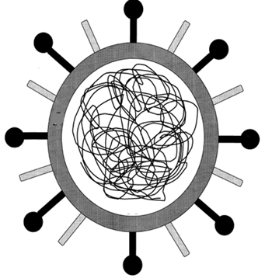
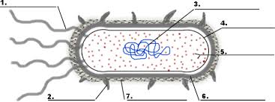

24. Matching
- _______Viruses that invade bacteria  - _______When a bacterium replicates its DNA and  divides in two identical cells is called  - _______In this type of viral infection, the DNA of the virus  enters the host cell and is inserted into its DNA  and stays dormant for a period of time.  - ______Cells that do not have a nucleus  - ______ ______Form of sexual reproduction in bacteria  In which bacteria transfer genetic information through  A tube like structure.  - ______This type of virus invades a cell, reproduces and is  scattered when the cell lyses and breaks  - _____A non-cellular particle made up of genetic material  and protein that can invade living cells | - Lytic cycle  - Conjunction  - Prokaryotes  - Bacteriophage  - Lysogenic Infection  - Binary Fission  - Virus

Unit 5: PHOTOSYNTHESIS CELLULAR RESPIRATION REVIEW

- _________________________is the process of splitting a glucose molecule into 2 pyruvic acid molecules.

- The molecule used by cells to store and transfer energy is ___________________

- Glycolysis happens outside the mitochondria in the ________________________________of the cell.

- ______________________________________________________happens when oxygen is present and includes glycolysis, Krebs cycle, and Electron transport.

- This describes a process that requires oxygen = ________________________________

- This atmospheric gas is required for aerobic respiration = _____________________________

- This describes a process that does NOT require oxygen; it means “without air”= ____________________________________

- Type of fermentation used by human muscles in low oxygen conditions and microorganisms to make yogurt, cheese, pickles, sauerkraut and kimchi. = ________________________________

- This 3 carbon molecule is produced during glycolysis when glucose splits in half ____________________________________

- Cell organelle which acts as the cell’s power plant to burn glucose and store energy as ATP __________________________________________

- If oxygen is NOT present, glycolysis is followed by ______________________________________

- Type of fermentation used to make bread dough rise and produce beer and wine
__________________________________________________

- The carbon atoms in pyruvic acid end up as _____________in the atmosphere following the Krebs cycle.

14. Which of the following shows the correct sequence during cellular respiration?
A. Electron transport chain → glycolysis → Krebs cycle
B. Glycolysis → Electron transport chain → Krebs cycle
C. Krebs cycle → Electron transport chain → glycolysis
D. Glycolysis → Krebs cycle → Electron transport chain

15. How many total ATP molecules are produced by 1 molecule of glucose completing cellular respiration ?

2 6 24 36

16. Which stage of cellular respiration produces the most ATP?
A. glycolysis
B. Krebs cycle
C. Electron transport

- Tell the kind of fermentation used in each example:
- Yeast use this to make bread dough rise ________________________

- Your muscle cells use this during rapid exercise when oxygen is low ________________

- Bacteria and yeast use this to make beer and wine _____________________

- Bacteria use this to make cheese, yogurt, and sour cream ___________________

- Compare and contrast aerobic cellular respiration with fermentation.
__________________________________________________________________________________________
________________________________________________________________________________________________________________________________________________________________________________________________________________________________________________________________________________________________________________________________________________________________________
19.

Rearrange the following pieces to create the equation for photosynthesis: Oxygen, Carbon Dioxide, Water, Glucose, Sunlight,

20.
Rearrange the following pieces to create the equation for respiration: Oxygen, Carbon Dioxide, Water, Glucose, ATP,

21. How are the equations for photosynthesis and respiration similar? How are they different? Which one captures energy and which one converts it?

22. What organelle is responsible for photosynthesis?

- What factors control the rate of photosynthesis?

24. Organize the following steps under the appropriate process and put them in the appropriate order.

Calvin Cycle (light-independent reactions), Glycolysis, Electron Transport Chain,
Light Reactions, Kreb Cycle

Photosynthesis Cellular Respiration

1. 1.

2. 2.

3.

Unit 6: DNA and Protein Synthesis
- Draw a DNA molecule

- What are the 3 components of a nucleotide?

- Describe semi-conservative replication.

- Define the following:
DNA-

RNA -

Protein-

Replication-

Transcription-

Translation-

5. Match the following terms to their corresponding description:
tRNA mRNA rRNA
a._____ attaches to the ribosome in the cytoplasm
b._____ brings the amino acid to the ribosome
c._____ delivers the message of DNA into the cytoplasm
d._____ combines with proteins to make up the ribosome
e._____ has a codon (3 bases) that matches with the triplet in DNA
6. Where is DNA found in the cell? ____________________
7. Where are ribosomes found in the cell? _____________________

8. The primary function of DNA in cells is to
a. serve as a storage form for unused nucleotides
b. occupy space in the nucleus to keep the nucleus from collapsing
c. store information that tells the cells which proteins to make
d. serve as template for making long, spiral carbohydrates

9. According to the base-pairing rules, guanine (G) binds with
a. cytosine (C) b. adenine (A) c. thymine (T) d. guanine (G)

10. During DNA replication, the enzyme DNA polymerase
a. separates the two nucleotide chains in a DNA molecule
b. constructs new nucleotide chains that are complementary to the chains in the original DNA molecule
c. breaks down the original DNA molecule into individual nucleotides
d. joins two DNA molecules into a single molecule

11. A section of one DNA strand has the sequence ACCGAGGTT. What is the sequence of an mRNA transcribed from this section of DNA?

a. ACCGAGGUU

b. ACCGAGGTT
c. TGGCTCCAA
d. UGGCUCCAA
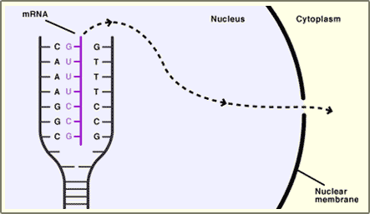
12. What process is shown in the diagram to the right?

a. replication
b. transcription
c. translation
d. protein synthesis

13. Draw an mRNA strand that is complementary to the DNA strand AATTGC. Circle a codon.

14. What happens if there is a mutation in the DNA sequence? What is the effect of a frameshift mutation?

Unit 7: Biotechnology Unit: Polyploidy, Hybridization, Gene, mutation, selective breeding, DNA Base Pair Rule, Inbreeding, restriction enzyme, gel electrophoresis, DNA polymerase, recombinant DNA, PCR, transgenic organism, plasmid, clone
Directions: Use word bank above to fill in appropriate term
Term (Fill in) | Diagram / Definition
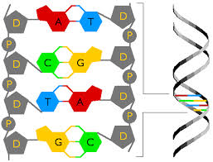

Adenine (A) pairs with Thymine (T)
Cytosine(C) pairs with Guanine (G)
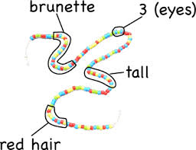

Segment of DNA that codes for traits such as hair color and height
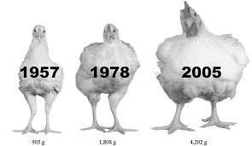

Choosing the “best” traits for breeding.
This is how pure breed dogs came to existence and common vegetables like corn.

Over the years chickens have been breed to produce a “more” meaty bird.
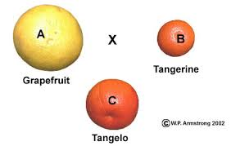

Crossing different organisms to bring out the best traits of each.

New fruit is made by combining two different fruits.

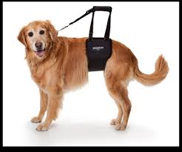
Hip Problems in Pure Breeds

Continued breeding of the individuals with the same characteristics.

Inbreeding, such as with Golden Retrievers, increases the likelihood of disease or deformities.
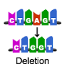

A Mutation is any change in DNA.

Deletion is when a segment of DNA is omitted from the sequence, therefore deleting that characteristic.
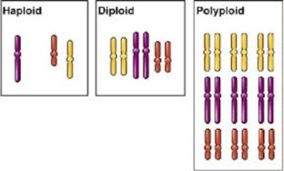
Means many sets of Chromosomes

Humans have 2 sets of chromosomes (23 pairs), but plants such as the banana can have 3 or 4 sets of chromosomes.
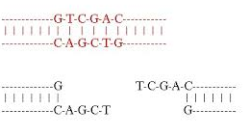
An enzyme used to cut DNA into specific fragments.

The DNA sequence has been cut between Guanine and Thymine.
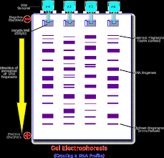

A method used to analyze DNA.

Small DNA pieces move farther away
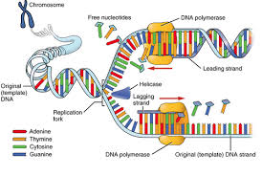
An enzyme that copies DNA.

The DNA polymerase follows along the “unzipped” DNA strand, filing in the base pair and creating a complete double helix again.
When a sequence of DNA from another organism or same organism is inserted into DNA.

Example: the DNA from a firefly is inserted into a mouse to make it glow.
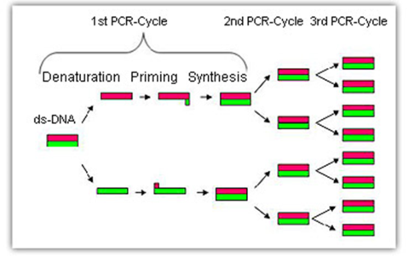
A technique used to copy a segment of DNA between the two primers.

Scientists make copies of sequences of DNA to help them manipulate and analyze it
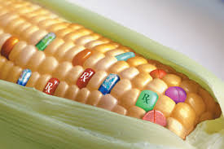
Disease fighting meds in corn
Also referred to as a Genetically Modified Organism (GMO).

Any organism that contains genes from another species.
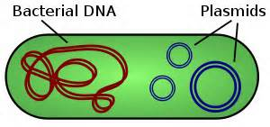

A small ring of DNA found in bacterial cells. Used to transport genes of a different organisms into the host cell
An organism produced from one cell that is genetically identical to the desired organism.
An exact copy.

- Explain the steps in making recombinant DNA (Hint: you need plasmid)

- List 3 advantages AND disadvantages of genetically modified foods.
Advantages:
1.
2.
3.
Disadvantages:
1.
2.
3.

