Honors Biology I Mid-Term Review Packet

Midterm Examination Outline / 2016-2017

This exam will cover all the material we have learned so far this year. It is highly suggested that you focus on class notes, past unit review sheets, Jeopardy review games and handouts when preparing for this exam.

sThe Science of Biology (Chapter 1)
- Living vs. nonliving things / the characteristics of life
- The scientific method
- Experimental methods (including controlled experiments)
- Data analysis /graphing / tables /interpreting data
- Dimensional analysis

Biochemistry/Enzymes(Chapter 2)
- Generalized structure of atoms
- Elements, molecules, compounds, ions
- Macromolecule types & function
- Chemical reactions/neutralization reactions
- Acids and bases and the pH scale
- Role of enzymes in chemical reactions

Cell Structure and Function (Chapters 3 & 4)
- Structure and function of cells (organelles)
- Transport of materials into/out of cells (diffusion, osmosis, active transport)
- Photosynthesis (transfer of light energy to chemical energy)
- Cellular respiration: aerobic and anaerobic
- Formulas for photosynthesis/respiration
- Fermentation

Bacteria & Viruses (Chapter13)
- Basic structure of bacteria & viruses
- How bacteria/virus is transmitted
- Treatment of bacterial/viral infection
- Use of bacteria & virus in daily lives (food, oil clean up, etc..)
- Prevention of transmission of bacteria/virus

Photosynthesis and Cellular respiration (Chapter 4)
- Photosynthesis (transfer of light energy to chemical energy)
- Cellular respiration (aerobic and anaerobic)
- Formulas for photosynthesis and cellular respiration
- Fermentation

DNA and Protein Synthesis (Chapter 5 and part of 6)

- DNA structure
- DNA replication
- Transcription and translation
- Mutations

Read each scenario and identify the IV, DV, constants, control group, experimental group. Write a title and state a hypothesis
Scenario #3: Aloe vera and Planaria
Jackie read that Aloe vera promoted healing of burned tissue. She decided to investigate the effect of varying amounts of Aloe vera on the regeneration of planaria. Planaria are aquatic flat worms that regenerate body parts when severed. Jackie bisected the planaria to obtain 10 parts (5 head sections and 5 tail sections) for each experimental group. She applied concentrations of 0%, 10%, 20%, and 30% Aloe vera to the groups. Fifteen mL of Aloe vera solutions were applied. All planaria were maintained in a growth chamber with identical food, temperature and humidity. On day 15, Jackie observed the regeneration of planaria parts and categorized the development as full, partial, or none.
Title: __________________________________________________________________

Hypothesis: _____________________________________________________________________________

_______________________________________________________________________________________

Independent variable (IV): _______________________________________________

Dependent variable (DV):_________________________________________________

Control Group (CG):_____________________________________________________

Experimental Group (EG):________________________________________________

Control Variables: ______________________________________________________________

How could you improve this experiment? ________________________________________________
________________________________________________________________________________________________________________________________________________________________________

Metric Conversion / Dimensional Analysis: Convert the following using railroad tracks
- Convert 55mm to meters

- Convert 60 kilograms to milligrams

Name the 8 characteristics of life, and give an example for each characteristic.
Characteristic | Example
1.

2.

3.

4.

5.

6.

7.

8.

Complete the following chart, naming the parts of the atom:
Particle | Location | Charge

- What is a covalent bond?

- What is an ionic bond?

- What is an isotope? Please provide an example of one.

Ions Review

- What is an ion?

Element | # Valence Electrons | # Electrons to gain | # of electrons to lose | Ion Formed / name
Li | 1 | none | 1 | Li+1/ Cation
S
Mg

pH

- Given the concentrations of [H+] and [OH-], how can we determine whether the solution is acidic or basic?

- Identify whether the following are acid or bases, and whether it has more H+ ions or OH- ions.

pH 2.3 = ________________________________________________________________________
pH 7.0 = ________________________________________________________________________
pH 13 = ________________________________________________________________________

Organic Chemistry is the study of all compounds that contain bonds between carbon atoms. Carbon has 4 valence electrons so its bonds are strong. Carbon even has the ability to bond with other carbon atoms, forming long chains or even rings. Living things are made up of molecules that consist of carbons covalently bonded to other elements, such as macromolecules. Fill in the following table.
Macromolecule  (polymer) | Monomer  “building blocks” | Polymers | Examples | Uses
 |  | Disaccharides-double sugars  Polysaccharides-many sugars | Glucose,fructose, galactose  Sucrose  Starch-plants  Glycogen-animals  Cellulose-plants  Chitin-insects
 |  | Saturated (all single bonds)  Monounsaturated (one double bond)  Polyunsaturated (two or more double bonds)  Phospholipids (phosphate replaces a FA) | Butter  Soft margarine  Olive oil  Cell membrane  Cholesterol  Testosterone  Progesterone  Beeswax (paraffin)
 |  | Dipeptide (2 amino acids)  Polypeptide (many Amino acids) | Enzymes  Muscles  Skin  Some hormones
Nucleic Acid | nucleotides | DNA  RNA | Stores and transmits genetic information | Template for protein synthesis  Carry genetic information

Enzyme Structure & Function
1. Most enzymes are what type of macromolecule? __________________________
2. Enzymes act as __________________ in reactions.
3. Are enzymes permanently changed in the chemical reactions they are involved in? Yes or No
4. Will an enzyme work on any substance? Explain.

5. Can enzymes be reused?
6. What ending is found on many enzymes?

7. Give 3 examples of enzymes with this ending.

8. How does an enzyme work?

9. What effect does an enzyme have on activation energy needed to start a reaction?

11. What is meant by the term substrate?

12. What is meant by active site?
13. What four factors can affect the activity of an enzyme? How?
- ex. Temp needs to be around body temp (98.6 F)
- _____________________________________________________
- _____________________________________________________
- _____________________________________________________
17. What is the effect of high temperature on an enzyme (running fever)?

18. What temperature do most enzymes do best at? _______________ºC
19. Most enzymes like a pH near ______________.
20. Explain how the shape of an enzyme is determined and why the shape is important to the function.

Use the 2 graphs below to answer Questions 21, 22, and 23.
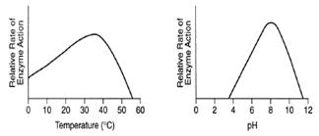

21. What is the optimal pH that this enzyme functions at? _________________________

- What is the optimal temperature that this enzyme functions at? __________________

- What happens when the pH is 2? ______________________________________________________________________

Unit 3: Cells and Cellular Transport Review Worksheet
Cells and Organelles
- List the levels of biological organization in multicellular organisms from most simple to complex.
(cell, organism, organs, molecules, organelles, compound(macromolecules),
organ system, atom, tissue)

- Make a Venn diagram comparing/contrasting prokaryotic and eukaryotic cells.
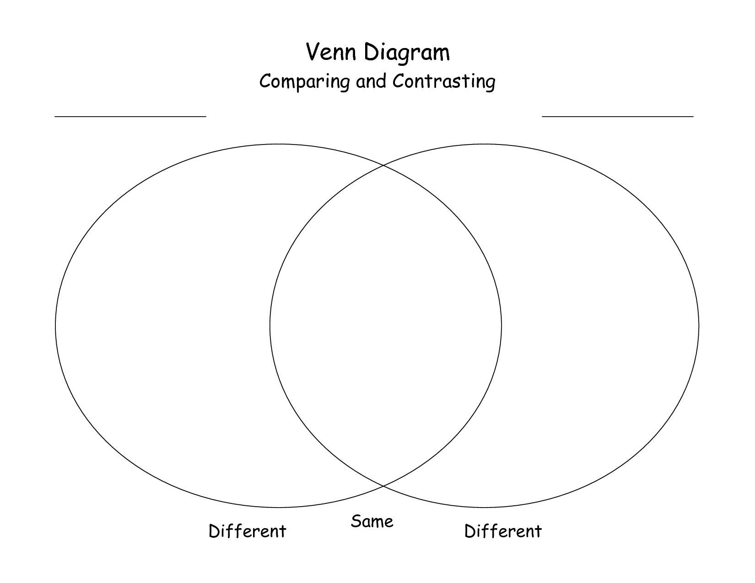

MATCHING: Match the terms below to the following descriptions.

A. ribosomes D. nucleolus G. plasma membrane J. lysosomes
B. cell wall E. cytoplasm H. rough endoplasmic reticulum K. Golgi apparatus
C. nucleus F. mitochondria I. Smooth endoplasmic reticulum L. vacuole
M. chloroplast

1_______ The structure in the nucleus which manufactures ribosomes for protein synthesis.

2_______ Cellular structure that regulates what enters and leaves the cell.

3_______ Organelles that store materials such as water, salts, and carbohydrates. They may occupy a large space within plant cells.

4_______ Helps to support, strengthen and protect the cell. Not found in animal cells.

5_______ Photosynthetic organelles found in many plant cells only.

6_______ A system of channels that transport proteins through the cell.

7_______ The liquid inside the cell that all the organelles are suspended in.

8_______ Organelles which provide cells with energy by using sugar as a fuel source.

9_______ Contain chemicals and enzymes necessary for digesting certain materials in the cell.

10_______ A system of channels that manufacture carbohydrates and lipids and transport them through the cell.

11_______ Organelle that collects, modifies and packages chemicals made at one location in a cell and secretes finished products to be used at another cellular local.

12_______ The organelle responsible for manufacturing proteins. (Be specific!)

13_______ The information and control center of the cell. Contains genetic information.

- Which organelles are only found in plant cells?

- List the organelles involves in assembly of protein, starting from the nucleolus, and explain the function each organelle. (nucleolus, ribosome, golgi body, endoplasm reticulum)

Cell Transport
      - Match the following substances with their description
X= Word Bank: solution
0= solvent
X+0= solute
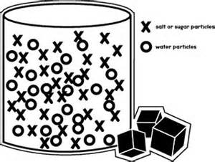
X represents sugar molecule
O represents water molecule
2. How is active transport different than simple diffusion and facilitated diffusion?
_________________________________________________________________________________________
_________________________________________________________________________________________

3. Why does a plant like celery get limp when placed in a hypertonic solution?
__________________________________________________________________________________________
__________________________________________________________________________________________

4. Complete the table by checking the correct column for each statement:
STATEMENT | Isotonic Cell(s) | Hypotonic Cell(s) | Hypertonic Cell(s)
1. The concentration of dissolved substances (stuff) in the solution is lower than the concentration inside the cell.
2. When a cell is placed in this solution, water will enter the cell by osmosis resulting in osmotic (turgor) pressure (causes a cell to swell).
3. The concentration of dissolved substances (stuff) in the solution is the same as the concentration inside the cell.
4. The concentration of dissolved substances (stuff) in the solution is higher than the concentration inside the cell.(causes a cell to shrink)
5. When this solution is injected into the body no cell disruption occurs because no net osmosis occurs.
6. Putting a plant in this solution will result in water loss and cause the plant to wilt.

- Explain the diagram below in terms of movement of particles during cellular transport.

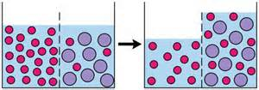

Write a definition for the following terms:

Passive Transport –

Active Transport –

Selectively Permeable –

Diffusion –

Facilitated Diffusion –

Osmosis –

Endocytosis –

Exocytosis –

1. Label the three images below as isotonic/ hypertonic/ hypotonic (with regard to the solution the cell is placed in)
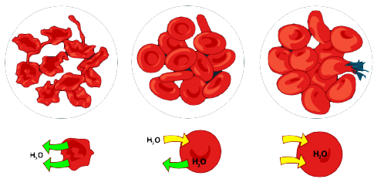
___________________ _________________ ___________________
2. Movement across the cell membrane that does not require energy is called
[ active / passive ] transport.
3. The difference in the concentration of a substance across a space is called a concentration [ equilibrium / gradient ].
4. If there is a concentration gradient, substances will move from an area of high concentration to an area of [equal / low ] concentration.
5. The cell membrane is [selectively permeable / impermeable ].
6. [Equilibrium / Diffusion ] is the simplest type of passive transport.
7. The diffusion of water through a selectively permeable membrane is called [osmosis / diffusion ].
8. The direction of water movement across the cell membrane depends on the concentration of free water [ molecules / solutions ].
9. A solution that causes a cell to swell is called a [hypotonic / hypertonic] solution.

Read the passage below and answer the following true/false questions.

A smaller cell has more surface area than a larger cell, so it is able to move materials in and out of the cell more efficiently, therefore is better at absorbing nutrients. To maintain homeostasis, when a cell becomes too large, it stops growing or is signaled to divide.

a) A smaller cell is more efficient than a larger cell at absorbing nutrients. True or False

b) As the cell size increases, its plasma membrane surface area True or False
becomes too small to absorb the amount of nutrients the growing cell
requires or excrete the increasing amount of waste it produces.

c) A cell can grow as large as it wants, as long as its environment provides True or False
enough nutrients

CELLULAR RESPIRATION VOCABULARY REVIEW

- _________________________is the process of splitting a glucose molecule into 2 pyruvic acid molecules.

- The molecule used by cells to store and transfer energy is ___________________

- Glycolysis happens outside the mitochondria in the ________________________________of the cell.

- ______________________________________________________happens when oxygen is present and includes glycolysis, Krebs cycle, and Electron transport.

- This describes a process that requires oxygen = ________________________________

- This atmospheric gas is required for aerobic respiration = _____________________________

- This describes a process that does NOT require oxygen; it means “without air”= ____________________________________

- Type of fermentation used by human muscles in low oxygen conditions and microorganisms to make yogurt, cheese, pickles, sauerkraut and kimchi. = ________________________________

- The ______________________________ cycle breaks down pyruvic acid into carbon dioxide and produces NADH, FADH₂, and ATP.

- This 3 carbon molecule is produced during glycolysis when glucose splits in half ____________________________________

- Cell organelle which acts as the cell’s power plant to burn glucose and store energy as ATP __________________________________________

- If oxygen is NOT present, glycolysis is followed by ______________________________________

- Type of fermentation used to make bread dough rise and produce beer and wine is
__________________________________________________

- The carbon atoms in pyruvic acid end up as _____________in the atmosphere following the Krebs cycle.

15. Which of the following shows the correct sequence during cellular respiration?
A. Electron transport chain → glycolysis → Krebs cycle
B. Glycolysis → Electron transport chain → Krebs cycle
C. Krebs cycle → Electron transport chain → glycolysis
D. Glycolysis → Krebs cycle → Electron transport chain

- How many total ATP molecules are produced by 1 molecule of glucose completing cellular respiration ?

2 6 24 36

List the amount of ATP that is produced at each stage.
- ____________________ __________________
- ____________________ __________________
- ____________________ __________________

17. Which stage of cellular respiration produces the most ATP?
A. glycolysis
B. Krebs cycle
C. Electron transport

- Tell the kind of fermentation used in each example:
- Yeast use this to make bread dough rise ________________________

- Your muscle cells use this during rapid exercise when oxygen is low ________________

- Bacteria and yeast use this to make beer and wine _____________________

- Bacteria use this to make cheese, yogurt, and sour cream ___________________

- Compare and contrast aerobic cellular respiration with fermentation.
__________________________________________________________________________________________
________________________________________________________________________________________________________________________________________________________________________________________________________________________________________________________________________________________________________________________________________________________________________

Rearrange the following pieces to create the equation for photosynthesis: Oxygen, Carbon Dioxide, Water, Glucose, Sunlight,

Rearrange the following pieces to create the equation for respiration: Oxygen, Carbon Dioxide, Water, Glucose, ATP,

1. Name the two major parts of photosynthesis and draw an arrow to where they take place in the Chloroplast to the left

1.

2.

2. Name the 3 chemical products of the light reactions. Which two get passed on to the Calvin Cycle? Which one leaves the leaf?

3. What is the product made in the Calvin Cycle?

4. How are the equations for photosynthesis and respiration similar? How are they different?

5. What organelle is responsible for photosynthesis?

6. What is the purpose of chlorophyll?

7. Organize the following steps under the appropriate process and put them in the appropriate order.

Calvin Cycle, Glycolysis, Electron Transport Chain,
Light Reactions, Kreb Cycle

Photosynthesis Cellular Respiration

1. 1.

2. 2.

3.
DNA and Protein Synthesis
- Define the following:
DNA-

RNA -

Protein-

Replication-

Transcription-

Translation-

2. Match the following terms to their corresponding description:
tRNA mRNA rRNA

a._____ attaches to the ribosome in the cytoplasm
b._____ brings the amino acid to the ribosome
c._____ delivers the message of DNA into the cytoplasm
d._____ combines with proteins to make up the ribosome
e._____ has a codon (3 bases) that matches with the triplet in DNA
3. Where is DNA found in the cell? ____________________
4. Where are ribosomes found in the cell? _____________________
5. The primary function of DNA in cells is to
a. serve as a storage form for unused nucleotides
b. occupy space in the nucleus to keep the nucleus from collapsing
c. store information that tells the cells which proteins to make
d. serve as template for making long, spiral carbohydrates

6. According to the base-pairing rules, guanine (G) binds with
a. cytosine (C) b. adenine (A) c. thymine (T) d. guanine (G)

7. During DNA replication, the enzyme DNA polymerase
a. separates the two nucleotide chains in a DNA molecule
b. constructs new nucleotide chains that are complementary to the chains in the original `DNA molecule
c. breaks down the original DNA molecule into individual nucleotides
d. joins two DNA molecules into a single molecule

8. A section of one DNA strand has the sequence ACCGAGGTT. What is the sequence of an mRNA transcribed from this section of DNA?

a. ACCGAGGUU

b. ACCGAGGTT
c. TGGCTCCAA
d. UGGCUCCAA
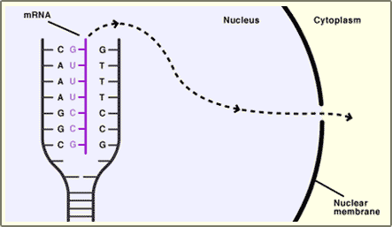
9. What process is shown in the diagram to the right?

a. replication
b. transcription
c. translation
d. protein synthesis

10. Draw an mRNA strand that is complementary to the DNA strand AATTGC. Circle a nucleotide.

11. Write a description explaining the process of making protein from DNA using the following terms: mRNA, DNA replication, transcription, translation, ribosome, tRNA, protein

12. What happens if there is a mutation in the RNA sequence?

13. Explain the process of DNA replication.

- Explain the process of transcription.

- Explain the process of translation.

- Discuss the difference between a gene mutation and a chromosome mutation.

- What is a frame shift mutation?

HK Biology Unit 4: Midterm Review Packet

Name______________________________________________ Date___________________ Class__________

- Most bacteria are ________________________ (autotroph / heterotroph) because they must get food from an outside source. However, cyano-bacteria can use the sun to produce food, therefore are called ___________________________. Some perform _____________________________, getting food from chemical compounds.
- The three shapes of bacteria are ____________________ (which is round/spherical), _____________________ (which is rod-shaped), and ___________________, (which is spiral-shaped).
- Some bacteria also have a tail, called a ________________________.
- In what ways are bacteria beneficial to us? ______________________________________________________________________________________
- To fight (treat) bacterial infections, ____________________________________ may be taken.
- Some ways to prevent bacterial infection are (list several ways)
________________________________________________________________________________________________________________________________________________________________________________________________________________________________________________________________________________________________________________________________________________________________________

- True / False: Disinfectants are used to destroy bacteria on nonliving inanimate objects.

- True / False: A pathogen is harmful to living organisms because it causes disease.

- Antibiotics are effective against ________________________but not ____________________.

- The process by which a dead or disabled pathogen (or proteins from that pathogen) is introduced into the body so that an immune response results without an actual infection is called?
A) Vaccination/Vaccine B) Antibiotics C) Bacteriophage D) Pathogenics

Matching
_____Photoautotrophs  _____Chemolithotrophs  _____Chemoorganotrophs | - Feed on organic matter.  - Use energy from the sunlight to produce glucose  - Feed on inorganic matter  - Feed on food already prepared for them

- Viruses are (living, nonliving). They are composed of an outer ____________________, with _________________________ inside.
- When a virus injects its DNA into the host cell, it hijacks the host, forcing it to _______________________the viral DNA. Once the viral proteins are assembled, the cell _________________________, releasing the viruses. This is referred to as the __________________________ cycle.
- If the viral DNA is not immediately copied, it becomes integrated within the host's ____________________. When the host cell divides, the daughter cells produced will also contain copies of the ________________. The virus may be ____________________ for several years in this state, but it is being spread. This is called the ___________________ cycle. Once it becomes active again, the lytic cycle will take over.
- ___________________________means disease causing, either from a bacteria or virus.
- Viruses do not respond to _______________________. The body produces interferons to help fight viruses. Humans can receive immunity from viruses through _______________________, which is when we are injected with dead or weakened viruses so that ___________________________ will be produced against it.

- The __________________ (lytic / lysogenic) cycle is a cycle of viral infection, replication, and cell destruction.

- Is the host cell destroyed during the lysogenic cycle? Yes or no?

- The protective outer coat of a VIRUS is called a _____________________.

- A typical ________________ (Bacteria / Virus) consists of a protein coat and a nucleic acid core of DNA or RNA. .

- Viruses are surrounded by a _________________ coat called a capsid.
  - A) polysaccharide B) Protien C) Lipid D) Carbohydrate

- Tell some reasons why viruses are NOT considered LIVING. (Short-answer).
______________________________________________________________________________________________________________________________________________________________________________________________________________________________________________________________________________________________________________________________________________________________________________________________________________________________________________

- Label the parts of the bacteria and virus below:
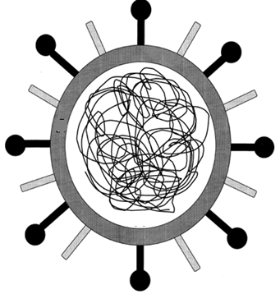
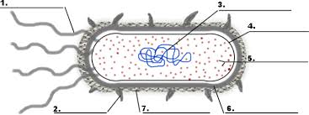

Matching
- _______Viruses that invade bacteria  - _______When a bacterium grows to twice its normal size  and replicates its DNA and divides is called  - _______In this type of viral infection, the DNA of the virus  enters the host cell and is inserted into its DNA  - ______Cells that do not have a nucleus  - ______The smaller group of prokaryotes that tend to live  in harsh/ extreme environments  - ______The process by which bacteria exchange genetic  information through a “bridge like” structure  - ______This type of virus invades a cell, reproduces and is  scattered when the cell lyses and breaks  - _____A non-cellular particle made up of genetic material  and protein that can invade living cells | - Lytic cycle  - Archae  - Conjunction  - Prokaryotes  - Bacteriophage  - Lysogenic Infection  - Binary Fission  - Virus

- What is a plasmid and describe unique characteristics of a plasmid.
- Label and describe the various stages of the lytic and lysogenic cycle.
- Discuss why it is important to take an antibiotic through the whole course of treatment.
- What is a “retrovirus”?
- Explain the difference between DNA and RNA containing viruses and why one type can change quickly and the other cannot.
- What is a glycoprotein and what is its function.
- List and describe: conjugation, transduction and transformation
- Discuss how bacteria are able to resist an antibiotic.
- How is the pig involved in a bird infecting a human with a virus?

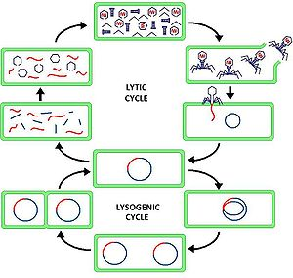
- Label/describe each stage in the diagram below.

