Name______________________________________ Period____ Date____________
Observing Nervous Responses
Background
The nervous system is composed of different conductive tissues that carry impulses to all parts of the body and is also responsible for the body’s responses. For example, your nervous system initiates many types of reflex actions. When you touch a hot object, you immediately pull your hand away. You might be aware of this reflex action occurring, but you are unable to stop or control it.
The brain processes stimuli from the environment through its five senses: sight, taste, touch, sound, and smell. Think of an example of how your brain processed each of these types of stimuli as you got ready for school this morning, write them in the space below.
Sight: ______________________________________________________________
Taste: ______________________________________________________________
Touch:______________________________________________________________
Sound:______________________________________________________________
Smell:______________________________________________________________

How do reflex actions occur? When your hand touches a hot object, heat receptors in the skin send an impulse to the muscles of the arm to contract. The impulse travels along the sensory neurons to the spinal cord. The impulse leaves the spinal cord, and travels through motor neurons to the arm muscles, causing them to contract and pull your hand away. This pathway is called the reflex arc. Because the reflex arc involves only the spinal cord and not the brain, a reflex action occurs in a matter of a fraction of a second, you are not able to control a reflex – it happens automatically.
In a non-reflex response an impulse must travel to the brain. The impulse takes the same path as in a reflex action but also goes to the brain. The brain interprets the stimulus and initiates an appropriate response. In this case, the time it takes to respond is measurably longer than the time required for a reflex arc. A person’s reaction time can be measured by how quickly he or she can perceive a stimulus and then react to it. Driving a car, playing hockey or hunting are examples of activities in which reaction time is very important.

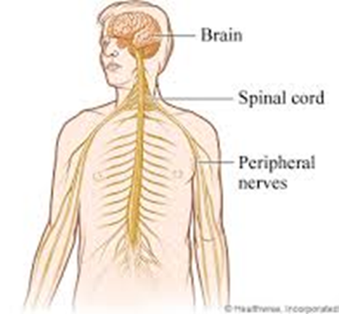
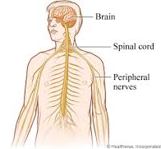
Draw arrows on the diagram below, demonstrating the reflex arc .
Include and label 1) sensory neuron 2) spinal cord 3) brain 4) motor neuron

Questions:
- Which type of response is faster, a reflex action or a non-reflex action? Why?

- Can you control a reflex action? Explain.

- List two examples of voluntary actions or other actions that would engage your somatic nervous system?

- List two examples of involuntary actions that would engage your autonomic nervous system?

Draw arrows on the diagram below demonstrating a non reflex response.
Include and label 1) sensory neuron 2) spinal cord 3) brain 4) motor neuron

Name: ________________________________ Period: ___ Date: ________________
Lab Partner (s): _________________________________________________________
Station 1: Reaction Time Pre-lab Questions
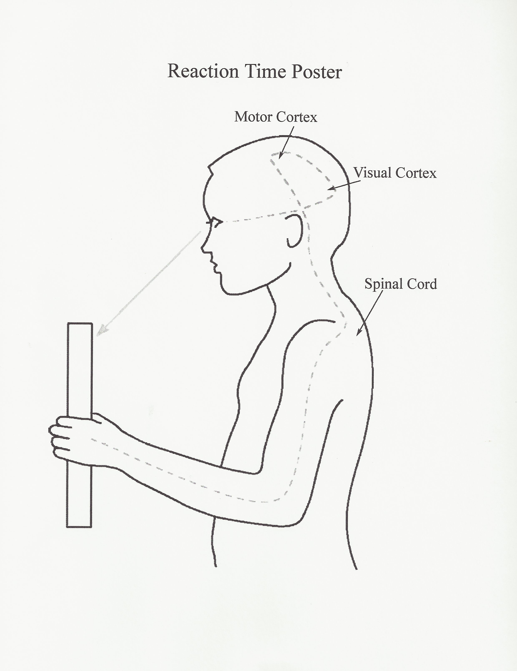
Reaction time is a measure of how quickly an organism can respond to a particular stimulus. Reaction time has been widely studied, many factors have been shown to affect reaction times, including age, gender, physical fitness, fatigue, distraction, alcohol, personality type, and whether the stimulus is auditory or visual.

The following describes your body’s visual response to catching a ruler.

First your eye sees the ruler. Then, your eye sends a message to the visual cortex in the cerebrum, which sends a message to the cerebellum. The cerebellum sends a message to the spinal cord. The spinal cord sends a message to the neurons to muscles in your hand/fingers. Finally, your muscles contract to allow you to catch a ruler.

The time it takes from when your eye first notices the falling to when your hand catches it is an example of reaction time. Even though your body may react quickly because messages are transmitted quickly along your nervous system, your body doesn’t react instantly. Many athletes spend hours practicing to improve their reaction time. In this activity, you will conduct a simple, measurable experiment (the ruler drop test) to study reaction time and hypothesize which stimuli your body can respond to quicker, auditory or visual.

A meter stick can be held perpendicular to the floor, dropped, and a student can catch it to determine how far it falls before the student reacts. The slower the reaction on the part of the student, the further the meter stick will fall. Differences in the reaction time of the student to different stimuli can be compared.

1. Write a problem statement:
(What are you trying to figure out / what is the overall question)
__________________________________________________________________________________________________________________________________________________________________________________________________________________

2. Guess which stimulus you can process faster: sight or sound. Use distance as your form of measurement. Write a hypothesis in the space below:

____________________________________________________________________________________________________________________________________________________________________________________________________________________________________________________________________________________________________________________________________________________________________________________________________________________________________

3. Independent variable: ______________________________________________________________________
4. Dependent variable: ______________________________________________________________________
5. A control group is not needed in this lab, why not? ________________________________________________________________________________________________________________________________________________________________________________________________________________________________________________________________________________________
6. Sketch a possible data table below for quantitative and qualitative data. Identify the units you will be using in your measurements.

Procedure:
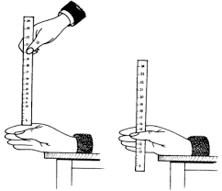
Part I: Visual Stimuli
- Obtain a meter stick.
- Sit down and rest the forearm of your dominant arm on a desk with your hand
- hanging over the edge
- Hold a meter stick vertically with the “0 cm” end down and approximately at waist height and the 100 cm end would be high in the air.
- Have your partner hold her writing hand with her thumb and forefinger held even with the bottom (0 cm end) of the meter stick with one digit on each side of it as if they were going to squeeze it.
- Prepare to drop the meter stick.
- Drop the meter stick and have your partner try to catch it as quickly as she can. Don’t give any verbal warnings of when you will drop it.
- Record the distance the meter stick fell before your partner grabbed it by looking at the number of the meter stick their fingers grabbed. Enter your data on to the data table.
- Repeat this procedure 2-8 a total of six times.
- Repeat for all the members in your lab group.

Part II: Auditory Stimuli
11. Repeat the procedure above, but this time have the “catcher” close his or her eyes. The dropper indicates when the meter stick is dropped by saying “Now”. It is very important that the dropper says, “Now” exactly when the meter stick is dropped.
- Record the distance the meter stick fell.
- Repeat the exercise for the other partners.

Name: ___________________________________ Period: ___ Date: ___________
Lab Partner(s): ________________________________________________________
Post Lab Questions:
- Which type of stimulus did your group respond to the best? Why? ________________________________________________________________________________________________________________________________________________________________________________________________________________________________________________________________
- Which type of stimulus did your group respond to the worst? Why? ________________________________________________________________________________________________________________________________________________________________________________________________________________________________________________________________
- Explain why a message moving along a nerve pathway takes time? ________________________________________________________________________________________________________________________________________________________________________________________________________________________________________________________________
- Is catching the meter stick a voluntary reaction or a reflex? Explain your answer.
________________________________________________________________________________________________________________________________________________________________________________________________________________________________________________________________
- How might this experiment change if you did this experiment with a person 70 years old? Why? ________________________________________________________________________________________________________________________________________________________________________________________________________________________________________________________________
- Name three occupations where having a fast reaction time is important. ________________________________________________________________________________________________________________________________________________________________________________________________
- How would the reaction time change in this experiment if you were distracted?
________________________________________________________________________________________________________________________________________________________________________________________________

