Peptidoglycan - The bacterial wonder wall
- By James Byrne on September 14, 2011
- Scientific American. Retrieved October 29, 2016

are on Twitter
Quick, can you describe your grandparents? Staphylococcus aureus, or the Golden Staph, can and it is a single cell. If you couldn't you should visit them more often. In any case, a very cool paper came out recently but before we can get there we need to begin by going backwards to explain a very important bacterial structure called peptidoglycan.
Peptidoglycan is a polymer of amino acids (hence the peptido-) and sugars (hence the –glycan) that makes up the cell wall of all bacteria. This structure is so fundamental to bacterial life that major functional division of bacterial species is based on the structure of this peptidoglycan layer, which can be exploited by a special staining protocol.
Back in 1884 a guy named Gram developed a staining technique to visualize bacterial samples (now called a Gram stain). It was really important because, as the story goes, pneumonia was a big problem at the time and there were three causes; unknown (later identified as viral pneumonia) and two types of bacterial pneumonia caused by either Streptococcus pneumoniae or Klebsiella pneumoniae. Importantly pneumonia caused by Streptococcus is more contagious and develops faster than pneumonia caused by Klebsiella, which tends to only affect the immuno-compromised. Gram’s stain, which was fast and definitive, allowed for the three different types of pneumonia patient to be grouped together, reducing spread and therefore preventing disease.
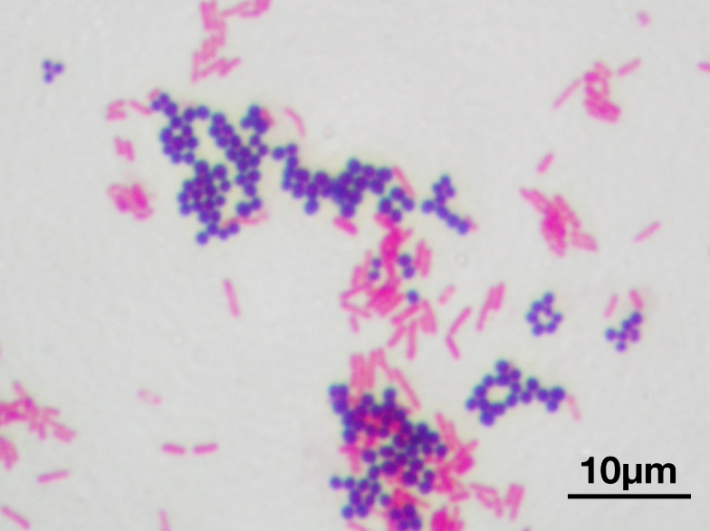
GRAM STAIN OF MIXED CULTURES OF S. AUREUS (PURPLE) AND E. COLI (RED). CREDIT: WIKIMEDIA.

So how did Gram’s stain work? Because of the peptidoglycan layer. The thickened peptidoglycan layer in Gram positive cells allows them to retain the stain (hence remaining ‘stain positive’ or ‘Gram positive) where as the thin layer seen in Gram negative cells cannot prevent the stain from leeching out (hence stain and Gram negative). Of course Gram himself didn’t know this but his stain was a success and it was 1884 so give him a break.

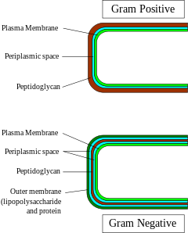
PRETTY SIMPLE PICTURE BUT EVERYTHING IS COLOUR CODED. CREDIT: WIKIMEDIA.

Peptidoglycan is also vitally important for the way antibiotics work. The role of a bacterial cell wall is defensive. The wall is there for the same reason our skin is on us, to keep the insides in and the outsides out and it does this by physically limiting the size and shape of the cell. In the microbial world one of the most important forces changing cell size and shape is, believe it or not, water.
A bacterial cell is a little salty bubble generally existing in a less salty environment. The problem lies in that the less salty environment wants to even out all the salt concentrations so water would rush into the cell to dilute its saltiness until it matches that of the environment, or until it bursts and kills the cell. This process is given the name osmosis. The role of peptidoglycan is to act as a physical barrier to the cell taking on to much water and killing itself. Its like trying to inflate a balloon inside a small box, once a certain amount of air goes in the box pushes back on the expanding balloon and no more air can be pushed into the balloon.
But suppose we could break this peptidoglycan wall, that would result in the bacterium losing this protective layer and becoming vulnerable to osmosis causing the cell to pop. Wouldn’t that be a great antibiotic? Turns out it is a great antibiotic, penicillin. Penicillin works by inhibiting the repair of the peptidoglycan layer, therefore damage compounds and the peptidoglycan is compromised causing the cell to become susceptible to osmotic lysis.
This also explains why penicillin and its derivative are more effective against Gram positive cells. With its peptidoglycan layer hidden beneath an outer lipid membrane it is harder for the penicillin to reach the peptidoglycan where it has activity whereas Gram positive cell walls leave the peptidoglycan exposed.
Penicillin is so good at killing bacteria that bacteria have had to evolve a way around it. They do this in two ways, they either destroy the penicillin itself or they change the target of penicillin to something penicillin can’t recognize. Either way our use of penicillin, and our exploitation of this peptidoglycan wall triggered an arms race with the microbial world so that they could protect the precious peptidoglycan.
[Material removed by L. caskey]
Peptidoglycan is a wonderful substance. Without it bacteria would be vulnerable to death by water, we wouldn’t be able to quickly, easily or cheaply tell them apart and we would be without penicillin, possibly the second greatest biomedical innovation after vaccines. Now it seems that peptidoglycan can control the site of cell division, in S. aureus anyway, indicating there might be more to discover about this bacterial wonderwall.

References:

Turner, R., Ratcliffe, E., Wheeler, R., Golestanian, R., Hobbs, J., & Foster, S. (2010). Peptidoglycan architecture can specify division planes in Staphylococcus aureus Nature Communications, 1 (3), 1-9 DOI: 10.1038/ncomms1025

van Heijenoort J (2001). Formation of the glycan chains in the synthesis of bacterial peptidoglycan. Glycobiology, 11 (3) PMID: 11320055

Homework Assignment:
Based on your understanding of this article, in your own words, explain
- how peptidoglycan is an important component of the cell wall of bacteria
- how peptidoglycan is used to identify bacteria
- how antibiotics destroy bacterial cells

