**Transgenic Bacteria using Recombinant Plasmid DNA**

**Objective**: You will be making a model of a transgenic organism. A transgenic organism is an organism that has genes from two different organisms. Bacteria that has had the human insulin gene inserted into the plasmid DNA of the bacteria is an example of a transgenic organism.

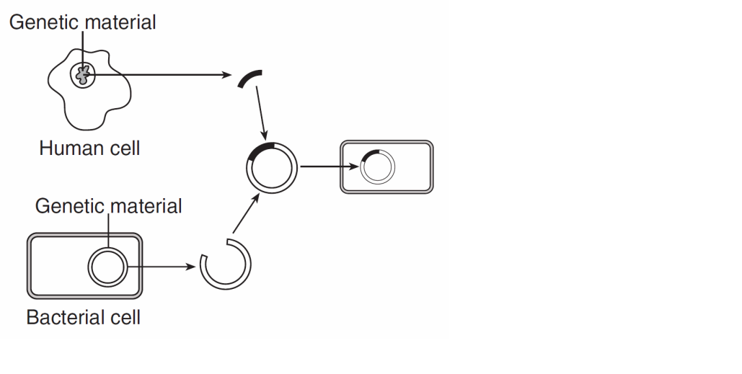

Transgenic Bacteria

Plasmid DNA

**PLASMID DNA PREPARATION**

1. Take out the plasmid DNA sequence strips (bright green sheet).
2. Cut out the strips of plasmid DNA and tape them together, so that you have a long strand of DNA. The order of the strips is not important, as long as the letters are facing in the same direction.
   1. What part of the DNA nucleotide do the letters on the strip represent? ___________
3. Tape the two ends of the plasmid DNA together. You should have a circular DNA strip – this is the plasmid DNA. Plasmid DNA is usually present in bacteria and is always arranged in a circle. This is your bacterial plasmid.

**HUMAN DNA BASE SEQUENCE PREPARATION**

1. Take out the DNA Base Sequence strips containing the human insulin gene on the pink sheet. Note the shaded portion represents the human insulin gene.
2. Cut the DNA Base Sequence strips and tape them together in **NUMERICAL ORDER**.

**APPLY THE RESTRICTION ENZYMES**

1. Take out the restriction enzyme cards you have been given. Each card shows a sequence where a particular restriction enzyme cuts DNA. List the number located at the bottom of the restriction enzyme cards you have been given: _______________________________________________
2. Compare the sequence of base pairs on each restriction enzyme card with the sequences of the plasmid base pairs.
   1. If you find a match between the enzyme card and the plasmid, mark the spot on the plasmid that matches with a **PENCIL**. Write the number of the enzyme next to the matching sequence.
   2. Repeat this step for each enzyme card that you have.

**Note**: Some restriction enzyme cards may have several matches and some restriction enzyme cards may have no matches.

1. Your plasmid DNA should only be cut one time. Examine your marks and identify the enzyme that cuts your **plasmid DNA** only one time. **Remove any enzyme cards that cut the plasmid replication site (shaded portion of the plasmid).** The replication site contains the gene that bacteria use to replicate, so that gene must remain intact.
   1. Which enzyme cards fits these criteria? You must have at least one card that fits these criteria, but you may have more than one card that fits these criteria. __________________
2. Compare the restriction enzymes you chose in step 8 against the **DNA Base sequence** strip. Find a restriction enzyme card that will make **two cuts** in the DNA. **One cut must be above the shaded insulin gene and one cut must be below the shaded insulin gene.** Mark the areas on the DNA strip that each restriction enzyme will cut and make a note of which restriction enzyme cuts in that spot. What is the number of the restriction enzyme cards that can make these cuts? You may have more than one card identified. ___________
3. Select **one** of the enzymes identified in step 9 to use to make the cuts in the DNA Base sequence strip. The goal is to cut the DNA strand as closely as possible to the insulin gene sequence without cutting into the gene sequence (Shaded portion). Once you have selected the enzyme, cut the plasmid DNA following the black dashed lines on the enzyme card. Make the same cuts on the DNA Base Sequence strip.

**CREATING THE TRANSGENIC BACTERIA WITH RECOMBINANT DNA**

1. Tape the sticky ends of the plasmid to the sticky ends of the insulin gene to create a recombinant DNA. In the lab, DNA ligase is the enzyme that binds the sticky ends together.

**Show your teacher the recombinant plasmid DNA you have made! ________ Teacher initials**

**Congratulations! You have successfully created a recombinant plasmid DNA. If this DNA were inserted into a bacterial cell you would create a transgenic organism. These bacteria will replicate and create more bacteria with the gene. Bacteria with the human insulin gene can be grown in the lab and can mass produce insulin for diabetics.**

Name: _____________________________ Period: ________ Date: _________

Assessment Questions:

1. Why was it important to find an enzyme that would cute plasmid at only one site?

What could happen if the plasmid were cut at more than one site?

2. Which restriction enzyme card did you use? ___________________

Ask other groups what they used and compare the final recombinant DNA plasmids.

Why might there be the transgenic plasmids be of different lengths?

1. Why was it important to discard any enzymes that cut the plasmid at the replication site?
2. Why is it important to cut the plasmid and the human DNA with the same restriction enzyme?
3. Do restriction enzymes exist naturally in organisms? If so, what is their purpose?
4. Why would restriction enzymes that created “blunt” ends not be as useful in recombination as those that create sticky ends?
5. In this activity, you made a model of a recombinant bacteria organism. For each of the following materials, indicate what they represent?

|  |  |  |
| --- | --- | --- |
|  | Molecule represented? | Function of the model? |
| Scissors |  |  |
| Tape |  |  |