Transgenic Bacteria using Recombinant Plasmid DNA
Objective: You will be making a model of a transgenic organism. A transgenic organism is an organism that has genes from two different organisms. Bacteria that has had the human insulin gene inserted into its’ plasmid DNA is an example of a transgenic organism.
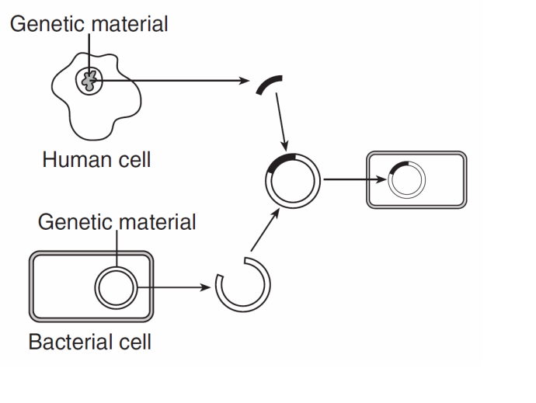
Transgenic Bacteria
Plasmid DNA

PLASMID DNA PREPARATION
- Take out the plasmid DNA sequence strips (bright green sheet).

- Cut out the strips of plasmid DNA and tape them together, so that you have a long strand of DNA. The order of the strips is not important, as long as the letters are facing in the same direction.
  - What part of the DNA nucleotide do the letters on the strip represent? ___________

- Tape the two ends of the plasmid DNA together. You should have a circular DNA strip – this is represents the plasmid DNA of the bacteria. Plasmid DNA is usually present in bacteria and is always arranged in a circle.
HUMAN DNA BASE SEQUENCE PREPARATION
- Take out the Human DNA Base Sequence strips containing the human insulin gene (Pink sheet).
- The shaded portion of the Sequence represents the human insulin gene. Do not cut across the shaded portion of the Sequence.
- Cut the DNA Base Sequence strips.
- Each strip has a number at the bottom. Tape the strips together in NUMERICAL ORDER.

APPLY THE RESTRICTION ENZYMES
- Take out the restriction enzyme cards you have been given. Each card shows a sequence of DNA base pairs where that restriction enzyme will cut the DNA.

- Write each number located at the bottom of each of the restriction enzyme cards you have been given: _______________________________________________

- Compare the sequence of base pairs on each restriction enzyme card with the sequence of the plasmid DNA base pairs.
  - Using a pencil, mark the location of matching base pairs on the plasmid that matches with a star.
  - Write the number of the enzyme card next to the matching sequence.
  - Repeat this step for each enzyme card that you have.
**Note: Some restriction enzyme cards may have several matches and some restriction enzyme cards may have no matches.**
- Examine your marks:
  - Identify the enzyme cards that cuts your plasmid DNA only one time.
  - Remove any enzyme cards that cut the plasmid replication site (shaded portion of the plasmid). The replication site contains the gene that bacteria use to replicate, so that gene must remain intact.
  - Which enzyme cards fits these criteria? You must have at least one card that fits these criteria, but you may have more than one card that fits these criteria. ___________

- Compare only the restriction enzyme cards you chose in step 12 against the Human DNA Base sequence strip. Find a restriction enzyme card that
  - Will make two cuts in the DNA.
  - One cut must be above the shaded insulin gene and one cut must be below the shaded insulin gene.
- Mark the location on the DNA strip that each restriction enzyme will cut with a star.
- Write the number of the restriction enzyme card that makes the cut in that spot.
- What is the number of the restriction enzyme cards that can make these cuts? You may have more than one card identified. ___________

- Select one of the enzymes identified in step 16 to use to make the cuts in the Human DNA Base sequence strip. The goal is to cut the Human DNA strand as closely as possible to the insulin gene sequence without cutting into the gene sequence (Shaded portion).

- Once you have selected the enzyme, cut the plasmid DNA in the correct location using the black dashed lines on the enzyme card as a guide. Make the same cuts on the Human DNA Base Sequence strip.

CREATING THE TRANSGENIC BACTERIA WITH RECOMBINANT DNA
- Tape the sticky ends of the plasmid to the sticky ends of the insulin gene to create a recombinant DNA. In the lab, DNA ligase is the enzyme that binds the sticky ends together.
Show your teacher the recombinant plasmid DNA you have made! ________ Teacher initials

Congratulations! You have successfully created a recombinant plasmid DNA. If this DNA were inserted into a bacterial cell you would create a transgenic organism. These bacteria will replicate and create more bacteria with the gene. Bacteria with the human insulin gene can be grown in the lab and can mass produce insulin for diabetics.
Name: _____________________________ Period: ________ Date: _________

Assessment Questions:
1. Which restriction enzyme card did you use? (1 pt)
___________________
2. Explain why you chose this enzyme (4 pts)

- What is the purpose of the replication site on the bacterial plasmid? (1 pt)

- Mrs. Caskey used a restriction enzyme that cut blunt ends in the plasmid and human DNA sequences. When she attempted to make a transgenic organism with these blunt ends, the new DNA was not inserted into the plasmid. Explain what happened. (1 pt)

- Mrs. Zukowski used one restriction enzyme to cut the plasmid and a different restriction enzyme to cut the human DNA. When she attempted to make a transgenic organism using the cut DNA, she was unsuccessful. Explain what happened. (2 pts)

- In this activity, you made a model of a recombinant bacteria. Describe each piece of the model and what molecule those pieces represent. (4 pts)

- Assessment Paragraph (11 pts)
Write one paragraph describing recombinant DNA technology and why we use it. You must define the term recombinant DNA technology and describe how this process is used to create a transgenic organism. Your paragraph must include appropriate terms defined in class, including all molecules, enzymes, and biotechnology terms. Describe an example other than the one described in this activity, in which recombinant DNA technology is used.

