College Prep Biology Review Sheet – Unit 8 Cell Division and Genetics

I. Vocabulary – Must know for the test!
a. centromere i. principle of dominance q. Punnett Square
b. homologous pair j. phenotype r. pedigree
c. sister chromatids k. genotype s. karyotype
d. principle of probability l. homozygous (dominant or recessive) t. autosome
e. chromosome m. mitosis u. cytokinesis
f. tetrad n. meiosis v. interphase
g. heterozygous o. gametes w. allele
h. principle of segregation p. nondisjunction x. gene/trait

II. Students should be able to:
A. Complete a monohybrid Punnett Square for round face (R).
Ex: Rr x RR

- List the phenotypes of the possible offspring:__________________________

- List the genotypes of the possible offspring: ___________________________

B. Complete a monohybrid Punnett Square for homozygous recessive and a homozygous dominant for bushy eyebrows (B).

- List the phenotypes of the possible offspring:__________________________
- List the genotypes of the possible offspring: ___________________________

C. Cross two heterozygous black guinea pigs.

- List the phenotypes of the possible offspring:__________________________

- List the genotypes of the possible offspring: ___________________________

- What is the probability the babies will be black? ________________________

- What is the probability the babies will not be black? _________________________

- Complete Punnett Square for F1 cross.

III. Pedigree Chart
- Following a Pedigree
The affected members of the family all have curly hair, a dominant trait in humans. Trace the curly hair in the following pedigree. For each person write their possible genotype below their symbol on the diagram.
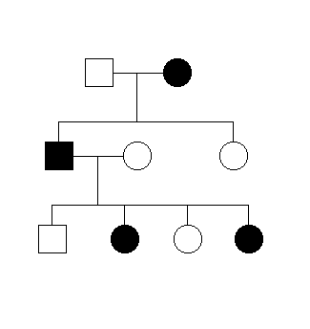
- Females are represented by:___________________
- Males are represents by:_______________________
- The shaded shapes represent:______________________________________
- How many generations are shown in the pedigree? ________

- The pedigree chart shows the inheritance of cystic fibrosis in four generations. Cystic fibrosis is caused by a recessive allele. (f)
- Is individual 2 in the figure above homozygous or heterozygous for cystic fibrosis?

- How many children of individuals 7 and 8 have cystic fibrosis?

- Predict the genotype and phenotype of individual 19 and 20.

IV. Be able to compare genetic disorders with infectious disease. Give one example of each and explain why each is a genetic disorder or an infectious disease.

