U1W1 Homework Honors Biology 2016

1. The three particles of an atom are: 2. The respective charges of each particle are:
a. ___________________ a. ______________
b. ___________________ b. ______________
c.____________________ c. ______________

3. In the image below indicate the location for each of the subatomic particles:

4. Use the periodic table to complete the following table below
Name of Element | Symbol of element | Atomic Number | Atomic Mass  (rounded) | # of Protons | # of neutrons | # of electrons
Gold
 | Si
 |  | 6
 |  |  | 22.99 (23)
 |  |  |  |  |  | 17
 |  |  |  | 53

5. What is a valence electron? _____________________________________________________________________________________

6. Give the valence electrons for the following elements:
a. Carbon: _________________
b. Hydrogen:_______________
c. Sodium: _________________
d. Neon: __________________
e. Oxygen: _________________

7. Show the distribution of electrons for each of the following elements in the images below:
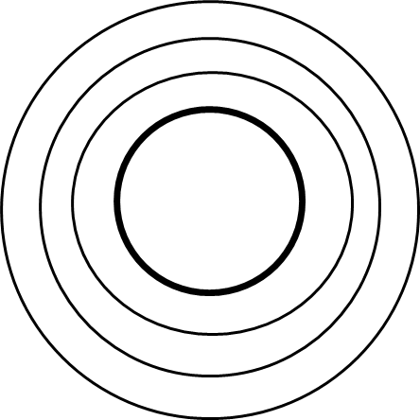
CARBON CHLORINE

8. What is an isotope? _____________________________________________________________________________________

9. Using your periodic table and the information given in the chart below, complete the chart below. The first one has been done for you as an example.
Element | Symbol | # of protons | # of neutrons in the isotope | Mass of isotope | Mass from periodic table | Name of isotope
Uranium | U | 92 | 143 | 235 | 238 | Uranium-235
Uranium |  |  | 146
Carbon |  |  | 8
Iodine |  |  | 78

