U1W2 Honors Biology – Bonding worksheet -2016 Name:_____________________________________________________

Study the diagrams below and answer the questions that follow.
Compound #1 Compound #2
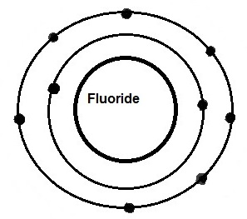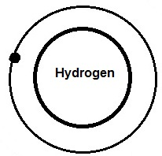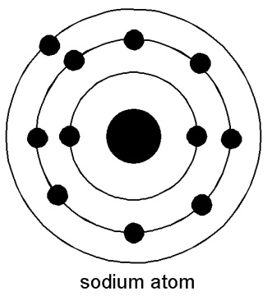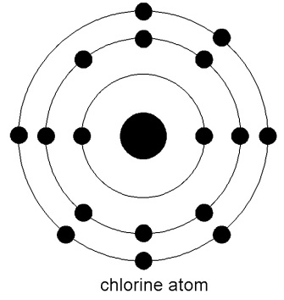
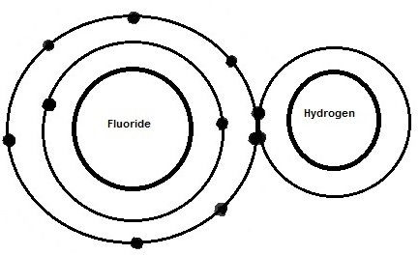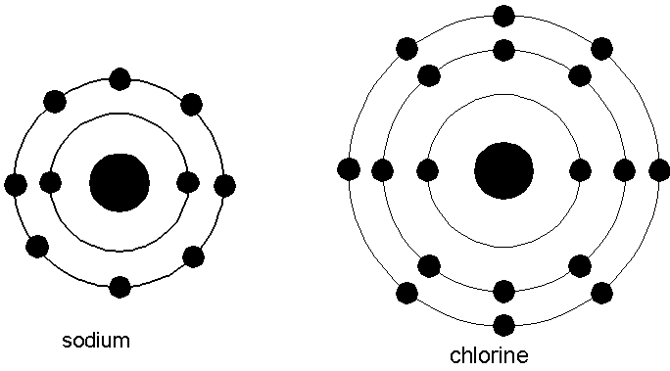

1. Which compound is formed by ionic bonding? Explain.

2. Which compound is formed by covalent bonding? Explain.

3. How many electrons are in the third energy level of the chlorine atom? ________and the fluoride atom?________

4. Which atom forms an ion by the loss of an electron? _________
What overall charge does this atom now have? ______
A positive ion is called a(n) ________________ and a negative ion is called a(n) ______________.

