Viruses “Scavenger Hunt”

Today, you will learn all about viruses by visiting various stations around the classroom while using a worksheet to guide you. For each question, go to the assigned website/read the article/watch the video and use the information to help you fill in the worksheet.

1. The Basics of a Virus – “What is a Virus? What is a Viral Infection?”

Use your textbook Chapter 13-16 to answer the following questions.

a) What is the definition of a virus?

b) The diagram below illustrates one type of virus. List the four parts of a virus and describe their functions. Label them on the diagram below.

2. Virus Morphology – “Four Shapes”

Article from: http://www.newworldencyclopedia.org/entry/Virus

Shape of Virus | Diagram of Virus | Example of Virus
3. Virus Reproduction: The Lytic Cycle (for bacteriophages) & The Lysogenic Cycle

3a. Virus Replication: LYTIC CYCLE Website: http://www.youtube.com/watch?v=wVkCyU5aeeU

The Lytic Cycle is a viral replication cycle, during which a virus takes over all metabolic activities of a cell and causes the host cell to die. Bacteriophages that ONLY reproduce using the lytic cycle are called a virulent phages.

As you watch the video, write down the name of each stage, and describe what is happening in each stage in point form.
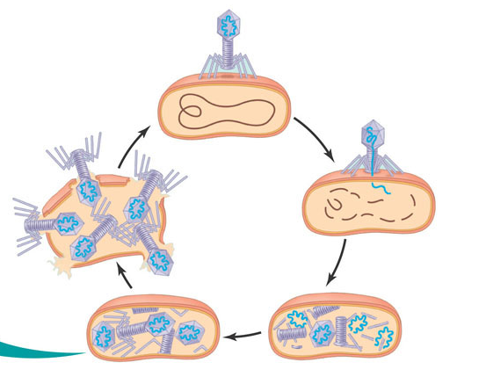

Stage of Lytic Cycle | Description of Stage of Lytic Cycle – What is happening?
3b. Virus Replication: LYSOGENIC CYCLE

Watch: http://www.youtube.com/watch?v=wLoslN6d3Ec and Textbook Printout

The Lysogenic Cycle is another type of viral replication cycle in which the genome of the phage is replicated without destroying the host. Phages capable of using both modes of replication (lytic and lysogenic) are referred to as temperate phages.
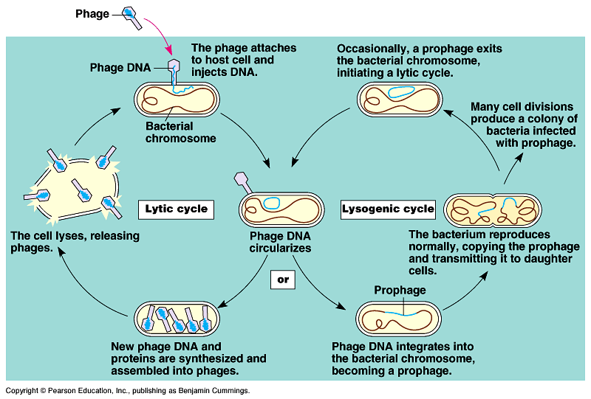

a) During the lysogenic cycle, the phage genome is mostly silent within the bacteria. Why?

b) What determines whether or not the lytic cycle or lysogenic cycle is entered?

4. Viral Infections – “What is a Viral Infection?”

Article from: http://www.medicalnewstoday.com/articles/158179.php

Viruses are very specific. That is, they only infect a very limited range of species and target certain organs and cells. These specific species/organs/cells are referred to the virus’ host range. Using the information found on this website, fill in the following chart for the given viruses.

Name of Virus | Organism, Tissue, Organ, or System Affected | How it Affects the Organism, Tissue, Organ or System
Measles

Shingles

SARS

5. Case Study – HIV/AIDS. Use your textbook.

- Label the following parts of the HIV virus.

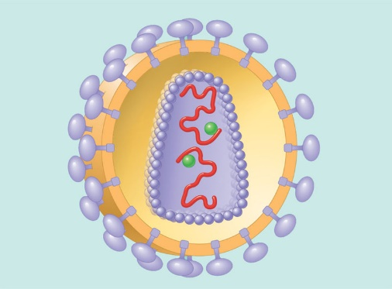

- Why is HIV called a retrovirus?

- Fill in the following chart using your textbook.

History of HIV | Transmission of the HIV Virus and Prevention
Treatment of HIV/AIDS  (You will need to conduct your own research to answer this question) | System/Cell Affected and How

Source:

